The Official Publication of ALOA—An International Association of Security Professionals

**CRIME**

**PREVENTION**

**\nd**

EVLOA 2007 lA/RAP-UP!

**PLUS!**

•Jew President’s First Message ****Jt***A**A*A*****2_QjQ|J **303**

scammers Discouer “Land of the Free” Breck H- CamP CML

**PO Box** 47070

3reg Perrg’s Vou LUant UJhat Locked? **Atlanta ga 30362-0070**

and MORE!



OUR STAND

WE RE IN BUSINESS TO HELP YOU

REDUCE DOWNTIME.

Commercial vehicle insurance designed to help you get back on the road.

When your vehicle is out of business, so are you. That's why Allstate provides fast and fair claim service. Youij local Allstate agent offers

commercial vehicle insurance as well as other insurance products designed to help keep your business in the race. Are you in Good Hands"?

**1-888-322-3078**

CALL NOW TO SPEAK TO AN ALLSTATE AGENT NEAR YOU.

**Subject to availability and qualifications. Allstate Insurance Company and Allstate Indemnity Company, Northbrook, IL. Allstate County Mutual Insurance Company, Irving, TX. Allstate New Jersey Insurance Company, Bridgewater, NJ. The "Cupped Hands" logo is a registered service mark and "Our Stand" is a service mark of Allstate Insurance Company. NASCAR® is a registered trademark of the National Association for Stock Car Auto Racing, Inc. © 2007 Allstate Insurance Compahy, Northbrook, IL.**

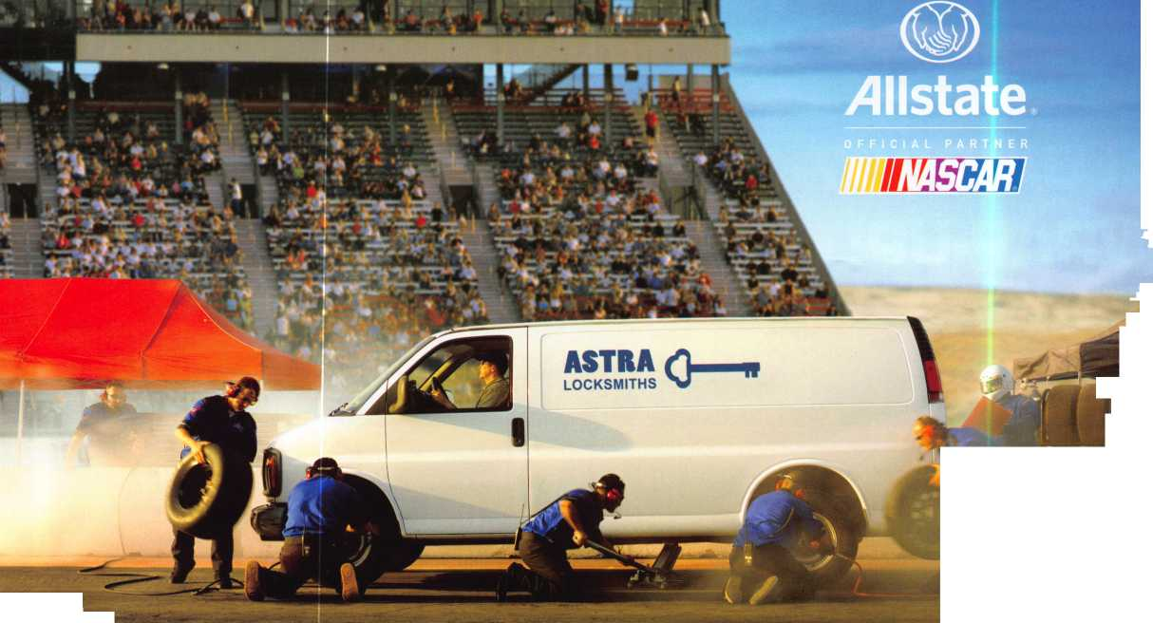

Just call 310-575-5074 and receive:

1. ALOA Index of Documents
2. Becoming a Locksmith (Ipg)
3. Locksmith Career Summary (3pg)
4. Locksmith School List (2pg)
5. ACE Class Schedule (8pg)
6. Certification lnformation(3pg)
7. PRP Category List (Ipg)
8. ALOA Membership Application(2pg)
9. ALOA List of Benefits (1 pg)
10. Scholarship Application Form (Ipg)
11. ALOA Video Library Order Form (1 pg)
12. ALOA Membership Items Order Form (Ipg)
13. Safe & Vault Technicians Association Member Application/Subscription Form (2pg)
14. ALOA Chapter Roster (3pg)
15. Legislative Action Network (2pg)
16. Legislative Action Network Newsletters (Ipg)
17. Various State Laws (1 Opg)
18. Industry Position Pager (Ipg)
19. Current Legislative Action Network Newsletters (Ipg)
20. Board of Directors Nomination Form (2pg)
21. ALOA Convention Registration
22. ALOA Board Expense Reimbursement & Request Form

**BEAUTIFUL ON THE OUTSIDE. INTELLIGENT ON THE INSIDE.**

Finally, electronic access control that looks as good as it works. Introducing the 5V-1 Door Lock System from SimonsVoss - the world’s first electronic access control system contained entirely inside the handle.

Backed by more than a decade of German engineering, this completely wireless, network-ready system can be used over 150,000 times without changing batteries. It’s time to experience the beauty of a keyless world.

[www.simons-voss.us](http://www.simons-voss.us)

414.421.2481

**Simons = Voss**

tech oologies

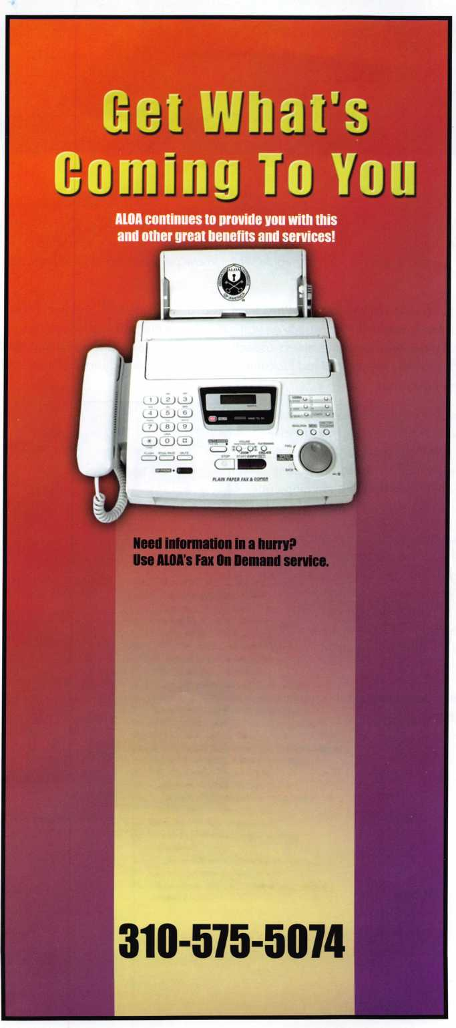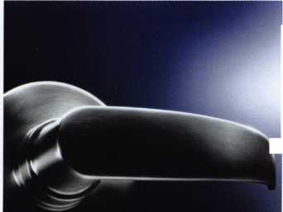

|  |  |  |
| --- | --- | --- |
| p r e s i d | e n 1 | Mai |
| view | p o i | n t |

Dear Members,

The Board and I would like to thank everyone who participated in this years voting. Our response  
was up, almost double from last year. This is your association and we encourage everyone to  
participate. You have elected a great bunch of people who I know personally and look forward  
to working with.

I have had the honor to serve under the last two Presidents, Bill Young, CML CPS and Bob Mock.

I appreciate all the guidance they have provided. As you get to know me and read these mes-  
sages, you will see that most will focus on business aspects. One of my goals is to show that most  
of you reading this are business owners not just locksmiths. We all love this industry but must real-

ize that we are running businesses.

This year's convention in Charlotte had many more business classes than ever  
before offered. Most were well attended. I hope to inspire more of you to take  
these classes so that we can all grow together. Jack Sims was our Keynote  
Speaker at the membership meeting on Friday morning. He spoke about mar-  
keting our business. The presentation that was video recorded that morning can  
be viewed the [www.aloa.org](http://www.aloa.org) website.

Every month I will end my message with a request from you, our members. If  
you have a suggestion that you think will make ALOA better and stronger,  
please email them to me at [president@aloa.org](mailto:president@aloa.org) or mail to PO Box 17944 Tam-  
pa FL 33682-7944. Please be sure to include your name and member num-  
ber, if you have one. I will not respond except to acknowledge that I have  
received your suggestion (if by email). I will present your letter to the board at  
the next meeting. Please make sure to read the minutes of the meeting to find  
out the outcome of your suggestion.

I have enjoyed the last four years as a board member of this great organiza-  
tion and look forward to my term as your President.

Thanks for you confidence in me to lead ALOA,

Ken Kupferman, CML CPS

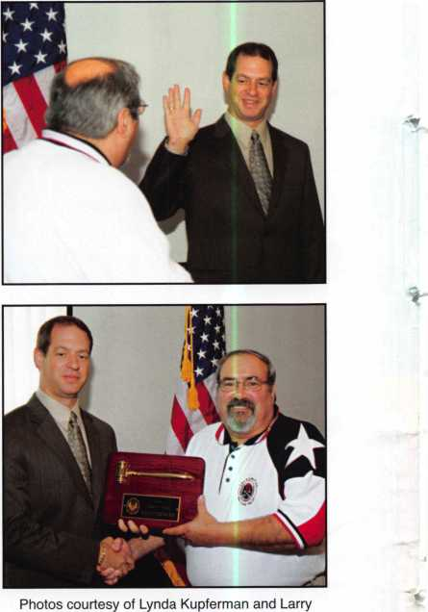

Patton of Wizard Safe and Lock, Clearwater, FL.

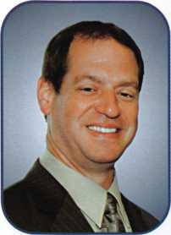

Keynotes • September 2007

**Stocking these manufacturers and more:**

**• Baldwin**

**• Falcon**

**> Kaba**

**• Kwikset**

**Pennsylvania 1-800-233-4210**

**Midwest**

**Missouri**

**» Monarch**

**Rocky Mtn.**

**Schlage**

**von Duprin**

**► Weiser Lock**

**► Weslock**

**[www.topnotch.bz](http://www.topnotch.bz)**

**[sales@topnotch.bz](mailto:sales@topnotch.bz)**

Top Notch Distributors, Inc.

We Know Service knows no boundaries!

Even in the midst of a natural disaster, like the recent flooding of our Honesdale, Pa. warehouse, Top Notch has the resources and ability to get the job done. Customer calls were seamlessly rerouted to our Missouri and Nevada locations. Our acclaimed customer service and dependable delivery never skipped a beat.

Here are just a few more reasons why Top Notch should be your first choice for Architectural Hardware products:

* Extensive selection of architectural styles and finishes
* Products in stock and ready for immediate shipment
* 99%+ order accuracy rate
* Knowledgeable staff averaging 15+ years of experience

Together, our people, our products and our ability to get the job done exemplify ... We Know Service.

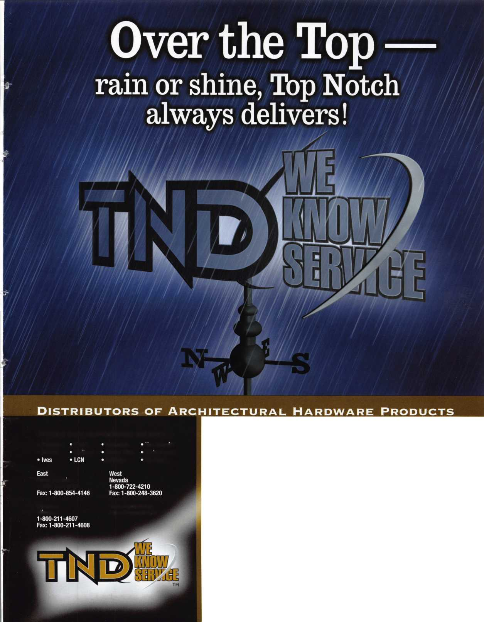

features

CRIME PREVENTION & ALOA 2007 RECAP!

10

Troubleshooting Digital Locks - The CSS Way

Find out what the Six Points of CSS Service Troubleshoot­ing are and how they can help you.

by Patrick Bales, CSS Service Department



ALOA 2007 Recap

Greg Perry recaps this year's successful 2007 ALOA Con­vention & Expo held in Charlotte, NC.

by Greg Perry; CM, CPS

**18**

Dugmore Dungan's School Security Solutions

In a school crisis situation time is critical and exposure to a threat needs to be avoided at all costs. Read on to find out the 3 main levels of school security.

20

Scammers Discover "Land of the Free"

Find out how the locksmith industry is giving a new mean­ing to the phrase "Land Of The Free".

by Jason Gage

22

Three New Schlage®

Commercial Products

Read about the 3 new Schlage® products lauched by gersoll Rand Security Technologies at the 2007 ALOA curity Expo.

In-

Se-

**28**

You Want What Locked?

Find out exactly what Greg Perrys customer wanted locked and what it took for the job to get done.

by Greg Perry, CML, CPS

|  |  |  |
| --- | --- | --- |
|  |  |  |
| AD INDEX |  |  |
| Allstate | Inside Front Cover |  |
| SimonsVoss | 1 |  |
| Top Notch | 3 |  |
| Videx | 7 |  |
| CSS | 11 |  |
| Locksmithing UNL | 12 |  |
| Symbiot | 13 |  |
| CCL | 15 |  |
| ALOA 2008 | 17 |  |
| Ingersoll Rand | 23 |  |
| Jet Hardware | 25 |  |
| H.L. Flake | 29 |  |
| Clearstar | 30 |  |
| Security Inc. | 33 |  |
| Safetech 2008 | 39 |  |
| A&B | 40 |  |
| Turn 10 | 40 |  |
| Coast Safe & Lock | 40 |  |
| Chase Paymentech Solutions. | 40 |  |
| PBP | 40 |  |
| Ultra Lift | 41 |  |
| INKAS | 43 |  |
| North Bennet Street School ... | 44 |  |
| Door Jam Armor | Inside Back Cover |  |
| Medeco | Back Cover |  |
| L |  | A |

**Departments**

|  |  |  |  |  |  |  |  |  |
| --- | --- | --- | --- | --- | --- | --- | --- | --- |
| Presidential |  | Executive | 5 | Calendar | 8 | Classified | 34 | Legislative 38 |
| Viewpoint | 2 | Applicants .... | 6 | Core | 9 | Associate Members | 36 |  |

Visit our NEW website at [www.aloa.org](http://www.aloa.org)

executive

S Af >



Volume 53, Issue 8

Additional contact information for the ALOA Board is available on the ALOA website—  
[www.aloa.org](http://www.aloa.org) or by contacting the ALOA office at 3500 Easy Street; Dallas, TX 75247;  
(800)532-2562; FAX (214)819-9736; e-mail [aloa@aloa.org](mailto:aloa@aloa.org).

Editor & Director of Creative Services

Betty Southerland [betty@aloa.org](mailto:betty@aloa.org)

Advertising Sales

Kim Hammond voice: 817-645-6778

Fax: 817-645-7599 e-mail: [adsales@aloa.org](mailto:adsales@aloa.org)

Executive Director

Charles W. Gibson, Jr., CAE [charlie@aloa.org](mailto:charlie@aloa.org)

Associate Executive Director

David Lowell, CML, CMST [david@aloa.org](mailto:david@aloa.org)

Convention & Meetings Manager

Jo Anne Mims [joanne@aloa.org](mailto:joanne@aloa.org)

Operations/Membership Manager

Mary May [mary@aloa.org](mailto:mary@aloa.org)

|  |  |
| --- | --- |
| Director of IT Operations  Greg K. Jackson |  |
| Comptroller  Kathy Romo | [kathy@aloa.org](mailto:kathy@aloa.org) |
| Membership Development Manager  Ellen R. McEwen [ellen@aloa.org](mailto:ellen@aloa.org) | |
| Convention & Meetings Assistant | Karen Lyons |
| Mail Room Coordinator | Kevin Wesley |
| Graphic Designer | ..Margarita Garza |
| Accounting Coordinator | Joyce Nixon |
| Assistant Education Manager | Bob Stafford, CML |
| Legislative Manager Tim McMullen, JD, CAE | |

Contributors

Jerome Andrews, CML  
Paul Chandler, CRL  
Claire Cohen, CML  
Brian Costley, CML, CMST  
Eric Costley, CRL

Ray D'Adamo, CML Billy Edwards, CML Dan Graffeo, CRL,CMST Jim Hancock, CPL Jeff Nunberg, CML, CMST

Randy Simpson, CML, CPP Robert Stafford, CML Dave Thielen, CML Greg Perry, CML,CPS

Tom Seroogy

Charles Stephenson, CPS

Dennis Watanabe, CML, CMST

Mission Statement: The Associated Locksmiths of America, Inc. is dedicated to enhancing the professionalism, education and ethics among locksmiths and those in related sectors of the physical security industry. With approximately 8,000 members in the United States, Canada and the free- world, ALOA is poised to help members obtain the knowledge, the strength, and the confidence to perform their role in the physical security field with pride and dignity. But it is only through active involvement and participation that ALOA can fully achieve its potential—and can help members to achieve theirs.

Policies: Keynotes® is the official publication of the Associated Locksmiths of America, Inc. (ALOA). Keynotes® acts as a moderator without approving, disapproving, or guaranteeing the validity or accuracy of any data, claim, or opinion appearing under a byline or obtained or quoted from an ac­knowledged source. The opinions expressed by the authors do not necessarily reflect the official views of ALOA. Also, appearance of advertisements and new products or service information does not constitute an endorsement of products or services featured by the Association. The Association does not ac­cept responsibility for the inaccuracy of any data, claim, or opinion appearing in this publication, due to typographical errors on the part of the authors, Association staff or its agents.

Editor's Note: This publication is designed to provide accurate and authoritative information in regard to the subject matter covered. It is provided and disseminated with the understanding that the publisher is not engaged in rendering legal or other professional services. If legal advice and other expert assistance is required, the services of a competent professional should be sought.

Authors' Payment: Payment for eligible submissions to Keynotes will be based on the following criteria: topic, time spent and past contributions. Authors who regularly submit to Keynotes® are generally paid a higher rate. The latter is especially true of authors who write to fit specific editorial needs and submit said copy by Keynotes® deadlines. As a general guideline: Average payment for a 750 word, business or light' technical article would be $200. Payment for a 1500 word article involving significantly higher time and research efforts would be $400.

Payment will not be offered for articles submitted by ALOA employees or members of the ALOA Board of Directors (unless material is of a technical na­ture), nor for articles submitted by a company that promote that company's products or services. ALOA reserves the right not to pay for articles submitted by an individual(s) that promote a particular company's products or services.

Disclaimer: The Associated Locksmiths of America, Inc., (ALOA), reserves the right to refuse any article for any reason. Additionally, ALOA reserves the right to edit, amend or modify any article submitted for publication in order to preserve technical accuracy, clarity, fairness or grammatical correct­ness. ALOA will make the best efforts to notify the author of any changes. The extent of ALOA's liability for any article or information contained therein will be a notice of correction or retraction in the next possible issue.

Keynotes® (ISSN 0277 0792) is published monthly except for the combined June/July issue by The Associated Locksmiths of America, Inc., 3500 Easy St Dallas, TX 75247-6416. Telephone: (214) 819-9733; FAX (214] 819-9736; e-mail [aloa@aloa.org](mailto:aloa@aloa.org). Subscription rates for members—$ 15.00 per year. Periodical class postage paid at Dallas, Texas. POSTMASTER: Send address changes to: Keynotes, 3500 Easy St., Dallas, TX 75247-6416. © Copyright 2003, All rights reserved. No part of the contents may be reproduced or reprinted in any torm without prior written permission of the publisher.

President

Ken Kupferman, CML, CPS  
(813) 232-7600  
[president@aloa.org](mailto:president@aloa.org)

Secretary

John Soderland, CML, CMST  
(414)327-5625  
[secretary@aloa.org](mailto:secretary@aloa.org)

Directors, Northeast

Tom Foxwell  
(410) 206-5772  
ned i rector@aloa. org

Robert D. DeWeese, CML, CPS  
(410) 285-0101  
ned i rector@a loa. org

Directors, Southeast

Tom Gillingham, Jr., CML, CPS  
(615) 300-3777  
sedirector@aloa .org

Steve Myslik, CRL  
(843) 321-9200  
sedirector@aloa .org

Director, North Central

William Smith, RL  
(920) 893-5282

Guy Spinello, RL  
(815) 394-1000  
ned i rector@aloa. org

Director, South Central

CD Lipscomb, CML, CPS  
(903) 874-3522  
sed i rector@a loa. org

Directors, Southwest

Greg Parks, CRL  
(858) 271-1155  
swd i rector@a loa. org

Gordon Racine, CML  
(719) 384-4707  
swd i rector@a loa. org

Director, Northwest

Keith E. Whiting, CML, CFL  
(360) 601-5656  
nwdirector@aloa .org

Director, International

Hans Mejlshede, CML  
(453) 539-3939  
[eurdirector@aloa.org](mailto:eurdirector@aloa.org)

Director, Associate

Dan Floeck  
(800) 231-4105  
asdi rector@a loa. org

Trustees

[trustees@aloa.org](mailto:trustees@aloa.org)

Robert E. Mock  
(856) 863-0710

Randy Simpson, CML, CPP  
(281) 240-5959

William Young, CML, CPS  
(610)647-5042

Past Presidents

2005-2007 Robert E. Mock  
2003-2005 William Young, CML, CPS  
2001-2003 Randy Simpson, CML  
1999-2001 John Greenan, CML, CPS  
1997-1999 Dallas C. Brooks  
1995-1997 David Lowell, CML, CMST  
1993-1995 Breck Camp, CML  
1991-1993 Henry Printz, CML  
1989-1991 Evelyn Wersonick, CML, CPS  
1987-1989 Leonard Passarello, CPL  
1985-1987 Joe Jackman, CML  
1983-1985 Stanley Haney, CPL  
1981-1983 Louis LaGreco, CPL  
1979-1981 John Kerr, RL  
1977-1979 Clifford Cox, CML  
1974-1977 Charles Hetherington  
1972-1974 Gene Laughridge  
1970-1972 William Dutcher, RL  
1968-1970 Constant Maffey, RL  
1966-1968 Harold Edelstein, RL  
1964-1966 William Meacham  
1962-1964 Robert Rackliffe, CPL  
1960-1962 Edwin Toepfer, RL  
1956-1960 Ernest Johannesen

Keynotes • September 2007



AL

Birmingham

James Nix

Homewood

Robert B. Harbison

Montgomery

John D. Woodruff

AZ

Phoenix

Barak K. Gavriel

CA

Castro Valley

Kevin Gambetti

Modesto

Edward Townsend Oakhurst

Hubert Miller

CO

Estes Park

Gordon Ulrickson

FL

Cantonment

Ray Clark

Coconut Creek

Rohan A. Kerrutt

Sponsor: Joanie Tarbet Dania

Howard Teamkin Vaughn Howard

Eustis

Robert W. Landrum

Largo

Gilles Deacur

Miami

Stephen Harris Luis Toro Joe Fernandez Ryan Karpinsky Juan Moore

Port Charlotte

William J. Boyd

Tampa

Robert W. Curry

Sponsor: Ken Kupfermon CML,CPS

GA

Conyers

Robert C. Watts

Savannah

John Bittner

Sponsor: Bruce T. Rahn CRL

Keith Rahn

Sponsor: Bruce T. Rahn CRL

GU

Tamuning

John D. Estes

Sponsor: Andrew Estes

IN

Hobart

David G. Thornton

MA

Salem

Matthew Whitmarsh

Sponsor: John R. Whitmarsh CRL

MN

Minneapolis

Douglas S. Wilson CPL

NC

Advance

Robert Ellis

Sponsor: David A. Paulsrud Sr, CML

Cary

Jack Walder

Concord

David Trimble

Pleasant Garden

Dan Clark

NH

Manchester

Richard G. Paradise

Sponsor: Richard S. Paradise CRL

NV

Pahrump

Jack F. Hill

NY

Amawalk

Anthony West CRL

Sponsor: Robert H. Stafford CML Babylon

Michael R. Siena

New York

Kevin Hall

SC

Clover

James Schronce

Florence

Bernice Medlin

Greenwood

Dennis J. Dill

TN

Knoxville

Robert Mogg

Sponsor: Marian M. Swann CRL Nashville

Michael L. Bibee

Sponsor: John C. Elliott Jr; CML, CPS

TX

Bridge City

Billy R. Garrett

Sponsor: Roy O. Yetter RL

VA

Vienna

Dale K. Mast

Sponsor: Keith S. Smith

Canada

ON

Brampton

Ronald Prince

Milton

Eddie Sturge

Sponsor: Thomas Fraser

Ottawa

Chris J. Nightingale



Sharqia

Mohamed Nazieh

Sponsor: Mohmed Abd El Mon- eim

Great Britain

Bedford

Ian Impey

Rugby

Ian Herrington

JAPAN

Kanagawa

Atsuo Yokoyama

Sponsor: Takashi Kuwana CRL Osaka

Yuuji Ozaki

Yokohamashi

Atsushi Chujo

Sponsor: Takashi Kuwana CRL Tokyo

Hiroyuki Okada

Sponsor: Takashi Kuwana CRL

Hiroshi Yoshimizu

Sponsor: Takashi Kuwana CRL

Chiaki Ogura

Sponsor: Takashi Kuwana CRL Yamanashi

Kazuya Takahashi

Sponsor: Takashi Kuwana CRL

Takumi Watanabe

Sponsor: Takashi Kuwana CRL Saitama-shi

Takatomo Narui

Sponsor: Takashi Kuwana CRL

*Code of Ethics. Protests, if any, shouS^Se^idc^^/to^e Memt»rs^p ^parilrnent^ and'nMjst^ s^n^.^rfwMemberslhip apphcanMaj'hCT^v^k^In thefr^ust^twoor

applicants are not locksmiths, but work in a security-related field. Apprentice Membership (AP) applicants have worked in the industry le^fan two years.

date, respectively, to ensure applicants meet standards of ALOA's

more years. Allied Membership (AL)

Keynotes • September 2007

2007 **Pacific Security**

conference

**Presented by The Pacific  
Locksmith Association**

**October** 9**-**13**,** 2007

Airport Holiday Inn and Conference  
Center Portland, Oregon

* 4 Days of Dynamic Classes
* Saturday Trade Show
* Excellent Education—PRP, CEU’s
* Associated Locksmiths of America, IR/Schlage,  
  DHI, Timemasters, NAPCO, assa/Abloy, DSC,  
  Medeco and the BEST Independent Instruc-  
  tors in the Country

ACE Classes Seminars PRP Exam Trade Show

**For more Information Contact: PacificSecurityConference.com Conference Info: Bill Botek 503.644.9881 Vendors: Richard Corvi 360.737.4390**

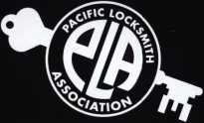

PLAN NOW

TO ATTEND THE 6TH ANNUAL PACIFIC SECURITY CONFERENCE

Members of security Industry associations will receive Class discounts

events

upcoming

|  |  |  |
| --- | --- | --- |
| 9/11-15 Clark Security Industry Tradeshow | 9/14-15 Doyle Annual Trade Show & Education | 9/19-22 Yankee Security |
| Anaheim, CA | Prior Lake, MN | Industry Tradeshow |
| Disneyland Hotel | Doyle Security Products | Sturbridge, MA |
| [www.clarksecurity.com](http://www.clarksecurity.com) | Mystic Lake Casino | Sturbridge Host Hotel |
|  | [www.doylesecurity.com](http://www.doylesecurity.com) | [www.yankeesecurity.org](http://www.yankeesecurity.org) |

9/21-23 ALNM Convention Farmington, NM Best Western Inn [www.alnm.us](http://www.alnm.us)

10/9-12 Pacific Security Conference Portland, OR Airport Holiday Inn & Conference Center pacificsecurityconference.com

9/24-26 ASIS Industry Tradeshow  
Las Vegas, NV

Las Vegas Convention Center  
[www.asisonline.org](http://www.asisonline.org)

10/9-12

Institutional Locksmiths Association Industry Tradeshow Willowbrook, IL Holiday Inn [www.ilanational.org](http://www.ilanational.org)

10/10-1 3 SERLAC Industry Tradeshow Orlando, FL Holiday Inn Resort, International Drive [www.serlac.com](http://www.serlac.com)

10/13-20 DHI 32nd Annual Conference & Expo Nashville, TN Gaylord Opryland Hotel [www.dhi.org/annual](http://www.dhi.org/annual)

|  |  |  |  |
| --- | --- | --- | --- |
| 10/20 | VLA Meeting & Class • Charlottesville, VA | 10/23-26 IFMA Industry Tradeshow | 10/25-28 GPLA Industry Tradeshow |
|  | Contact: Elliot Paul Conner | New Orleans, LA | Cherry Hill, NJ |
|  | va _locksmith@verizon. net | New Orleans Convention Center | Clarion Hotel & Conference Center |
|  |  | [www.ifma.org](http://www.ifma.org) | [www.gpla.org](http://www.gpla.org) |

**UPCOMING ACE CLASSES**

September 11-15, 2007 September 14-15, 2007 September 15, 2007 September 19-21, 2007 September 21-23, 2007 September 29, 2007

October 8-13, 2007

October 9-12, 2007

October 12 & 13, 2007

October 20, 2007

November 3 & 4, 2007

November 7, 2007

November 8-10, 2007

November 16-18, 2007

December 3-8, 2007

Anaheim, California • Clark Security Products Safe Lock Manipulation, Safe Lock Servicing,

Transponder Servicing • Joan Emrick • 858-9746737 Minneapolis, MN • Doyle Security Show For a complete listing contact:

Kristina Larsen • 612-521-6226 • [www.doylesecurity.com](http://www.doylesecurity.com)

Roseville, Ml • Locksmiths Security Association

Intermediate Auto Lock Servicing w/L-03 PRP

Marc A. Dearing, CRL • 810-244-4038/[mkdearing@comcast.net](mailto:mkdearing@comcast.net)

Sturbridge, MA • Yankee Security Convention

For a complete listing contact: Stephen McKinney

800-209-8266 • [www.yankeesecurity.org](http://www.yankeesecurity.org)

Farmington, NM • Association Locksmiths of New Mexico

For a complete listing contact: Wayne Wilkins, CRL

505-632-6641 • [clasicrez@yahoo.com](mailto:clasicrez@yahoo.com)

Colorado Springs, CO • CSCLA • [www.csclaco.org](http://www.csclaco.org)

Motorcycle Locksmithing w/L-22 PRPP

Phillip Poindexter • 719-269-4109

Phillip. Poindexter@doc. state.co. us

Appleton, Wl • Fox Valley Technical College

[www.ftvc.edu/security-crimeprevention](http://www.ftvc.edu/security-crimeprevention)

6-Day Basic Locksmithing Course

Jerry Antoon • 800-735-3882x2482 • [antoon@fvtc.edu](mailto:antoon@fvtc.edu)

Portland, OR • Pacific Security Conference • [www.pla-pro.org](http://www.pla-pro.org)

For a complete listing contact: Keith Whiting

360-601-5656 • [kwinwa@yahoo.com](mailto:kwinwa@yahoo.com)

Kansas City, MO • Missouri-Kansas Locksmith Association

Advanced Automotive Lock Service

Transponders the Complete Story

Bob Turner • 816-525-5522

Omaha, NE • Nebraska Chapter of ALOA

Keyless Mechanical Lock Service w/L-20 PRP

Elmer Howard • 402-676-8973 • [safeman@cox.net](mailto:safeman@cox.net)

Connecticut • Nutmeg Locksmith Trade Association

Defense Against Methods of Entry

Safe Lock Servicing for Locksmiths

Bill Brooks, RL • 203-269-7643

Baltimore, MD • Clark Security Products

Safe Lock Servicing, Transponder Servicing

Joan Emrick • 858-974-6737

[www.clarksecurity.com/Events](http://www.clarksecurity.com/Events). a$px?event=Easternre

Dallas, TX • ALOA Training Center • [www.aloa.org](http://www.aloa.org)

Three Day Professional Lock Hardware Installer

ALOA Education • 800-532-2562x104 • [education@aloa.org](mailto:education@aloa.org)

Ft. Wayne, IN • Northern Indiana Chapter of ALOA

PRP Exam, Domestic Auto w/L-03 PRP, Foreign Auto w/L-04 PRP

Jeremy Rodocker, CML, CPS • 260-459-1500

[rodockers@hotmail.com](mailto:rodockers@hotmail.com)

Dallas, TX • ALOA Training Center • [www.aloa.org](http://www.aloa.org) ALOA Education • 800-532-2562x104 • [education@aloa.org](mailto:education@aloa.org)

**UPCOMING PRP Sittings**

**9/14/07**

9/16/07

9/22/07

9/23/07

9/23/07

9/29/07

**10/5/07**

10/6/07

10/7/07

10/12/07

10/14/07

10/20/07

10/28/07

**11/2/07**

11/11/07

11/16/07

Friday 8:00am • Dallas, TX • ALOA Certification ALOA Training Center • [education@aloa.org](mailto:education@aloa.org) 800-532-2562x104

Sunday 8:00am • Anaheim, CA • Joan Emrick

Clark Security Products • [joan.emrick@clarksecurity.com](mailto:joan.emrick@clarksecurity.com)

858-974-6737

Saturday 9:00am • Sturbridge, MA • Steve McKinney Yankee Security Convention • [info@yankeesecurity.org](mailto:info@yankeesecurity.org) 800-209-8266

Sunday 10:00am • Farmington, NM • 505-632-6641

Association Locksmiths of New Mexico

Wayne Wilkins, CRL • [classicrez@yahoo.com](mailto:classicrez@yahoo.com)

Sunday 1:00pm • Muskego, Wl • John Soderland, CML, CMST

[prolock@aol.com](mailto:prolock@aol.com) • 858-974-6737

Saturday 4:30pm • Toronto, ON • John Malo

Jovan Distributors, Inc. • [lmalo@jovanlock.com](mailto:lmalo@jovanlock.com)

416-288-6306

Friday 8:00am • Dallas, TX • ALOA Certification ALOA Training Center • [education@aloa.org](mailto:education@aloa.org) 800-532-2562x104

Saturday 9:00am • Pueblo West, CO • Mike Middick Central & Southern Colorado Locksmiths Association [captkeyman@bresnan.com](mailto:captkeyman@bresnan.com) • 719-275-7787 Sunday 8:00am • Syracuse, NY • Ron Smith, CPL, CJIL Central New York Locksmiths Assn. • [advsl@imcnet.net](mailto:advsl@imcnet.net) 315-782-0912

Friday 6:00pm • Portland, OR • Jim French Pacific Security Conference • [frencje@yahoo.com](mailto:frencje@yahoo.com) 503-235-4000

Sunday 8:00am • Orlando, FL • James Barnhardt, RL SERLAC • [questions07@serlac.com](mailto:questions07@serlac.com) • 800-845-5294 Saturday 6:00pm • Charlottesville, VA • Elliot Paul Conner, CML Virginia Locksmiths Assc. • 703-440-8326 va_locksmith@verizon. net

Sunday 8:00am • Cherry Hill, NJ • Robert Shuetrumpf, CRL, CJIL Greater Philadelphia Locksmiths Assc. • 856-486-9280 Friday 8:00am • Dallas, TX • ALOA Certification ALOA Training Center • [education@aloa.org](mailto:education@aloa.org) 800-532-2562x104

Sunday 8:00am • Baltimore, MD • Joan Emrick

Clark Security Products • [joan.emrick@clarksecurity.com](mailto:joan.emrick@clarksecurity.com)

858-974-6737

Friday 3:30pm • Fort Wayne, IN • Jeremy Rodocker, CML, CPS Northern Indiana Chapter of ALOA • [rodockers@hotmail.com](mailto:rodockers@hotmail.com) 260-459-1500

**Contact the ALOA Education Department for a list of classes and training offered in-house.**

core



Allied Barton Security Services Do

AlliedBarton Security  
Services' Lawrence  
Loesch, Vice Presi-  
dent/General Man-  
ager and Daniel J.  
Gallagher, President,  
Western Region  
were photographed  
making the com-  
pany's annual

$50,000 donation to Pamela Delaney, President and  
Chief Executive Officer of the NYC Police Foundation  
on behalf of Crime Stoppers last week. AlliedBarton  
Security Services, [www.AlliedBarton.com](http://www.AlliedBarton.com), the largest  
American owned and managed security services firm,  
actively supports the Crime Stoppers Program of the  
New York City Police Department. This year marks Al-  
liedBarton's second installment of $50,000 on their  
total three-year pledge of $150,000. The Crime Stop-  
pers Unit [www.nycpolicefoundation.org/crimestop-  
pers.asp](http://www.nycpolicefoundation.org/crimestop-pers.asp) operates a hotline that allows anyone with  
important information about a violent crime in New  
York to provide information anonymously. "Crime Stop-  
pers is one of the best examples of a successful public-  
private partnership," said Lawrence Loesch, Vice  
President/ General Manager of AlliedBarton Security  
Services New York City region. "With the public's  
help, it has solved over 4,300 violent crimes including  
some of the city's most violent and high-profile cases.  
Our streets are safer today because of the men and  
women of the NYPD and its leadership. AlliedBarton is  
honored to contribute to this important program and  
we encourage other New York City corporations to  
contribute to this noble and highly effective organiza-  
tion."

nates $50,000.00 to Crime Stoppers

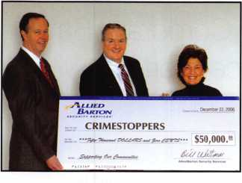

ALOA Remembers George Hall, CML



ALOA has learned of the passing of  
George Raymond Rathbun Hall, CML,  
3/28/49- 6/29/07 who died as a result of  
an automobile accident. George, a lifelong

resident of St. Paul, Minnesota, was a 34 year member  
of ALOA, an ALOA ACE Instructor and a former ASIS  
and DHI member. George was a pioneer at a very  
young age in the Minnesota Locksmith Guild which be-  
came the Minnesota Chapter of ALOA. He is survived  
by his sister, brother, his loving wife Paula, four chil-  
dren and two grandchildren.

NASTF Marks First Anniversary of Incorporation

As the National Automotive Service Task Force enters its second year as a formal organization, it is a good time to review positive accomplishments as well as look to the future. Although NASTF has existed through the efforts of many hard-working volunteers for many years, last summer marked the beginning of the newly formed 501 (c)-6 organization. In addition to continuing its five+-year history of facilitating communication be­tween independent repair facilities and original equip­ment manufacturers upon identification of a gap in availability of information, NASTF is highlighting sev­eral accomplishments during the past year:

* Ongoing work on the Secure Data Release Model (SDRM), which will give appropriately qualified and registered technicians and locksmiths a means of ac­cessing key codes and other types ofsecurity data and service support systems
* Establishment of a Collision Repair Committee to ad­dress those issues unique to the collision industry
* Launch of a redesigned website incorporating a new logo, a new color scheme, and other improvements

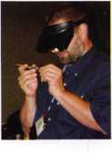

You Ought to be in Pictures!

Visit [www.aloa.org/pics](http://www.aloa.org/pics) for more images from the  
2007 ALOA Convention and Security Expo.

Troubleshooting Digital Locks — The CSS Way

By Patrick Bales, CSS Service Department

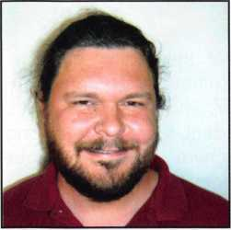

With over 142,000 phone calls for help re-  
ceived last year alone, it’s not hard to see that  
the service representatives at Corporate Safe  
Specialists get a lot of practice working with  
digital locks.

The CSS take on the average service call is this: an aver­age small retail store can do $10,000 worth of sales daily. When a manager tries to fix his or her own prob­lem, then in only 30 minutes, they’ve wasted over $400 poking at the safe’s keypad. Changing the practice of “blind poking” to a guided proper troubleshooting ses­sion can help get them back to their business and back to their day.

CSS service representatives resolve most digital lock problems over the phone by checking the Six Points of CSS Troubleshooting, which address most issues with digital keypads. CSS Service would like to share their tools of the trade with locksmiths.

1. Power - Not all power problems result in a dead key­pad. If a keypad makes odd noises or doesn’t respond, or if the battery is more than 1-2 weeks old, the battery may be running low on power. Change the battery to a new, name-brand alkaline. Power issues also may in­volve broken cables or wires, failure to make sufficient contact with the battery posts, or a battery that was in­serted backward. More serious cases may find a severed lock cable.
2. Lockout - This is also called “Penalty mode” by some. When a safe user has entered an incorrect combi­nation several times in succession, the keypad will enter Lockout mode, and while this is in effect the keypad cannot be used.

A locked-out keypad will resume its normal functioning in about 10 minutes if no one touches the buttons or at­tempts to remove the batteries during that time. The only way to get a keypad out of Lockout mode is to leave it alone.

1. Correct Usage - Is the customer entering the combina­tion correctly? Are they hitting extra keys when entering the combination? Are they entering their ZIP Code or bank PIN instead of the combination? Is the keypad set on a timelock that prevents access to the safe? Or does it require a key to be turned at the same the combination is entered?
2. Reset Code - Call CSS Service to check availability of a reset code. This code can cause the digital keypad to revert to its factory default settings.

Keynotes • September 2007

. ■:.: ; ';

Authenticated Access

NEXT LEVEL OF SECURITY AND ACCESS CONTROL

o Authenticated access - Only those with registered fingerprints can access safe

o Active Capacitive Technology - Reliable and only a live finger will open lock

° Backlit LCD - Signals when lock is open, easy to enroll and delete fingerprints

o Top-mounted fingerprint reader - Easy access

° Multiple user codes - Up to eight pass codes per lock

O Easy retrofit - Fits in the same space as most existing locks

° 24/7/365 live technical support - support when needed

E

**MNC4**

ms

Biometric Locks for Increased Security

With biometric locks you no longer need to worry about losing, forgetting or sharing the combination or PIN to your safe. Increase security with positive identification for safe access by combining a users fingerprint with a pin number. Your finger is your code and only those whose fingerprint has been registered can open the lock. Cash losses and internal theft are an unfortunate reality and since 1988 CSS has been helping to make retail and restaurant establishments more secure.

© 2007 Corporate Safe Specialists, 14800 S. McKinley Ave, Posen, IL 60469

TO MOVE AHEAD

To purchase a safe with a biometric lock, or upgrade your existing lock, please contact a CSS representative today at **(800) 342-3033 x200.**

To learn more about Corporate Safe Specialists' full range of biometric safes, products, services and cash management solutions, please visit [www.corporatesafe.com](http://www.corporatesafe.com).



*Security » Innovation » Service*

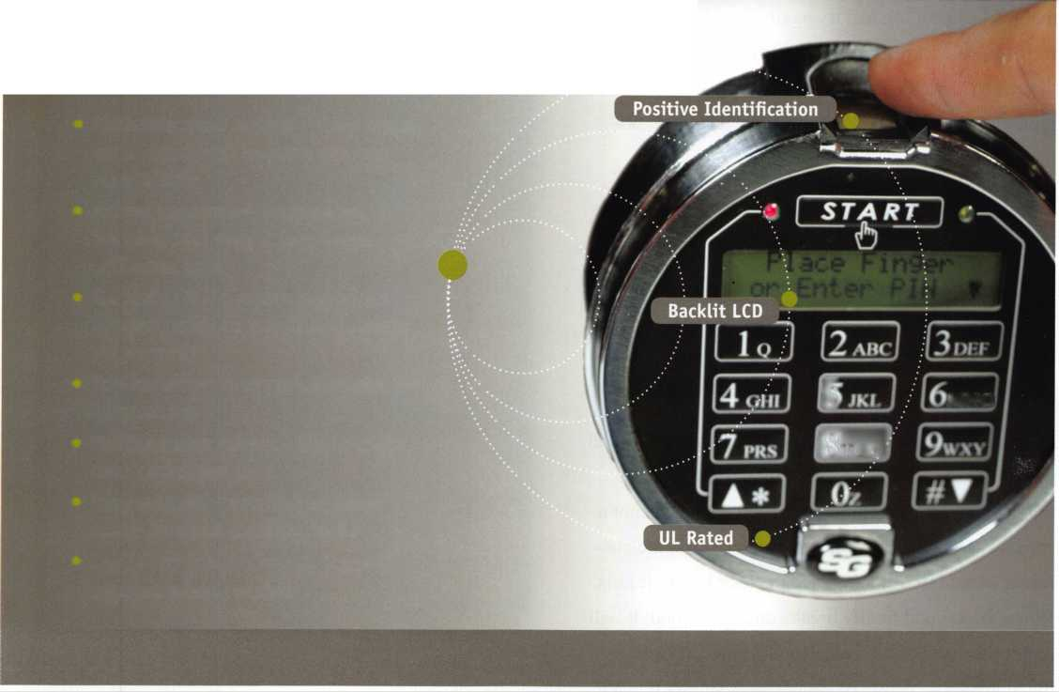

1. End Pressure - When pressure is applied to the end or side of the lock bolt, it can prevent the bolt from re­tracting properly.

To relieve end pressure, wiggle or shake the safe han­dle back and forth, then return the handle to its nor­mal, locked position and try again. To relieve pressure from the other direction, push on the safe door as though trying to push it shut. While applying this pressure, enter the combination again and try to un­lock the door.

1. Failed Lock - Rough use can cause digital keypads to break down before the end of their expected life cycle. Frequency of use, environmental conditions, and exposure to water (the restaurant environment can be prone to this) can all contribute toward an early breakdown. Look at the safe’s surrounding for clues.

A good store manager will always try to save time and money for the store. However, using a safe keypad that’s long past its recommended service date is not a sure way to save either time or money. It’s in the cus­tomer’s best interest to replace the lock before it fails. When the keypad finally breaks down for good, it will require the safe to be professionally opened - at a much greater expense, of course, than simply replac­ing the lock.

The Six Points of CSS Service Troubleshooting are easily remembered with the phrase “Please Let Char­lie Run Even Faster”: Power - Lockout - Correct Usage - Reset Code - End Pressure - Failed Lock. Rule out each of these areas in your troubleshooting, and you will isolate the problem.

*“Please Let Charlie Run Even Faster”.*

Power - Lockout - Correct Usage Reset Code - End Pressure - Failed Lock. Rule out each of these areas In your troubleshooting, and you will isolate the problem.

Punch SARGENT blanks  
to factory specifications.

BP201-SGT

Chip Tray

Try them at:

Yankee Security Conference - Sept. 22-23  
ILA-Oct. 12 • GPLA-Oct. 27

Available Exclusively from:

**Locksmithing, Uni. LLC  
302-575-0993  
[www.sargentpunch.com](http://www.sargentpunch.com)**

**2**

Keynotes • September 2007

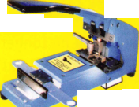

**Increase** Your

Bottom Line

Symbiot manages a seamless property service solution fojr its  
large regional and national customers through its Network of  
independent, qualified property service professionals.

Hr

Symbiot and its Network provide customers with a one-stop  
solution to meet all of the building/property needs, including:

I §

Locksmithing  
Snow Removal  
Landscaping  
Pest Control  
Plumbing  
HVAC  
Electrical  
Painting  
Custodial  
General Repair  
Pavement Maintenance

Ice companies that participate in Symbiot’s

ave access to purchasing programs, busi

networking/knowledge-sharing events

^ SYMBIOT

11781 S. LONE PEAK PARKWAY

SUITE 100 DRAPER, UT 84020 888-233-5518 801-307-0730 FAX: 801-307-0731 EMAIL: [networks@symbiot.biz](mailto:networks@symbiot.biz) [www.symbiot.biz](http://www.symbiot.biz)

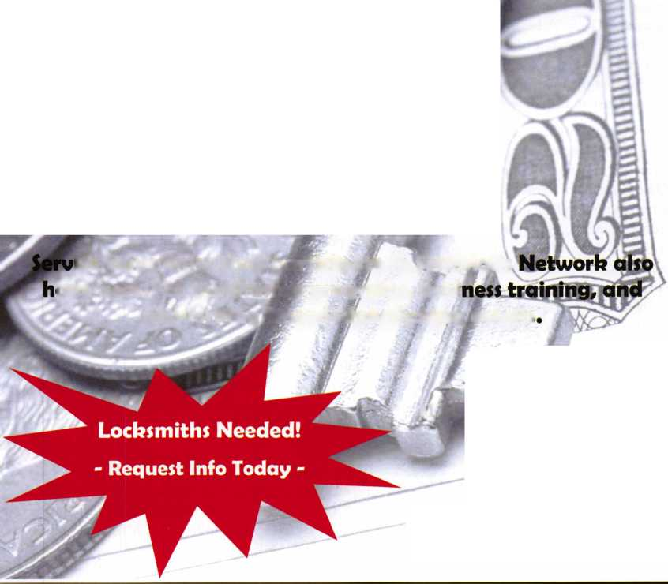

**I**

'34 **=**

*1000rimin Q

**-1**

'0ALOA 2007

7

8

**REVIEW**

By Greg Perry, CML, CPS

The successful ALOA Convention and Security Expo was held in Charlotte, NC. Let’s take a look at this convention and learn how it comes together.

The planning for a convention begins years in advance by choosing the location and signing contracts. The work begins in earnest before the prior year’s convention ends when exhibitors are asked to sign up for the next year. Instructors are reminded to return their call for presentations and sign up to instruct the following year. Even next year’s host city sends a representative to the convention.

Several months in advance of the convention the education depart­ment checks with all the instructors to request any handouts and ma­terial lists. If necessary, instructors are asked to ship equipment and supplies to Dallas for ALOA to send them to the convention site in one of the two semi-truck trailers used to haul materials to the con­vention site. Once at the convention site, the logistics fun begins.

Just imagine trying to move your office and lock shop to another part of the country for two weeks each year! Materials are unloaded into the education office and staged for the different classes. Each night, several employees and volunteers move pallets of materials between the classrooms, education office, and trailers. During the day, scores of people register attendees, directing them to appropriate rooms and making sure things run smoothly. The ALOA convention is often a family affair as members and staffers bring extra help and extra hands from home to volunteer. The volunteers run lunch chits, class roosters and fulfill many other tasks. Others help in the Education Office moving materials. Breaks and lunches are staffed and photog­raphers take pictures for the Daily newsletter. Speaking of the Daily, have you ever wondered how it is published? While attendees are en­joying a late dinner or sleeping, the day’s events and photos are com­piled, a layout is completed before the Daily goes to press at a local all-night print shop and is then returned for folding. It magically ap­pears bright and early the next morning for delivery to the break areas.

This year, Charlotte, North Carolina hosted a fantastic education conference and convention! The students experienced over 11,000 classroom hours from some of the best instructors available in over 120 classes. The convention hosted over 180 exhibitors introducing new products and giving us a great reminder of some of the old stan­dards.

Charlotte is a beautiful southern town. The convention center is on the south end of a downtown area that offered many different restau­rants and museums. The area offered lots for families as well as adults. Daytona Beach, Florida may be the headquarters for NASCAR, but Charlotte, North Carolina is the heart of NASCAR. Lowe’s Motor Speedway is nearby in Concord and most of the driv­ers and teams call the area around Charlotte home. The Saturday night dinner banquet was held at the Speedway. This was a great lo­cation for a banquet. The Speedway offered a number of simulators that were kept busy all night. It’s not often you get to feel what its like to sit behind the wheel of a racecar.

The convention week itself began on Sunday with two very fitting classes, “Fundamentals of Locksmithing” for those just starting their career and “Instructor Training” for those reaching out to become mentors. Hopefully, in another 5 to 10 years, the students in this year’s “Fundamentals of Locksmithing” class will be back to take the “Instructors Training” class! The “Instructors Training” class is a lot of fun and provides you with insights usable beyond the classroom.

The week continued with classes on all forms of locksmithing from “Aluminum Storefront Door Servicing”, “Automotive, Combination Lock Servicing and Manipulation”, “Basic Electricity” and “Elec­tronic Access Control” classes to “Forensic Locksmithing and Mas­terkeying”. Fellow members and factory trainers taught these classes. Some of these instructors have been teaching for years. Others are new and up and coming. Be sure and thank them next time you meet one of them.

Eleven scholarship recipients were hosted at the convention this year. These students benefit greatly from the education provided. Some are at the beginning of their career. Others have many years under their belt and the classes extend their skill level.

Every year, a golf tournament is held during the convention to bene­fit the ALOA Scholarship Foundation. This year a check for $13,000 was presented to the ALOA Scholarship Foundation president Gor don Racine by Tom Demont of ASSA, on behalf of ASSA, Medeco, and Arrow. The prize sponsors were ASSA (shirts and hole in one prizes), Stattec (Golf Balls), AMSEC (Hats), and Lucky Line (Bag tags).

There were 57 paticipants. Mark Hokanson won the Men's division and Jill Trego won the Women's division.The tournament was held at the Arnold Palmerdesigned golf course at Birkdale in Huntersville, NC, voted the best new course in the state. Each year, many more scholarships are given out for ALOA members to attend local and na­tional convention classes.

The results of the ALOA board elections were announced at the membership meeting. Congratulations to Ken Kupferman, CML, CPS, our new President; Directors, Guy Spinello, RL, Bill Smith, RL, Greg Parks, CRL, Gordon Racine, CML, Tom Gillingham, CML, CPS, and Steve Myslik, CRL, and lastly to Bob Mock our newest Trustee and most recent Past President. Bob indicated how much fun and how fast the past two years have elapsed. He truly enjoyed being



Keynotes • September 2007

**The name you can trust for  
travel safety, security & accountability.**

*Stifles &, Colors for tvery Lifestifle*

* Recognized & Accepted by the TSA
* Security Window cannot be altered with a paper clip
* Security Window can only be reset by a person knowing the combination
* Zinc Die Cast Body (Not Brittle Plastic)
* Steel Shackle is virtually unbreakable

Security Window

O

Red Window:

Luggage has been searched.

O

Green Window:  
Lock Not Opened.

Protected by U.S. Patents 6,877,345 and 7,007,521. The Design of the Lock is a Registered Trademark* of The Eastern Company.



**Security Products** A Division of The Eastern Company **A Proud Union Company. (S.E.I.U.)** 301 West Hintz Road | Wheeling, IL 60090 | Telephone: 800.733.8588 | Fax: 847.537.1881 **vvww.cclsecurity.com**



**TRAVEL SENTRY**

**APPROVED**

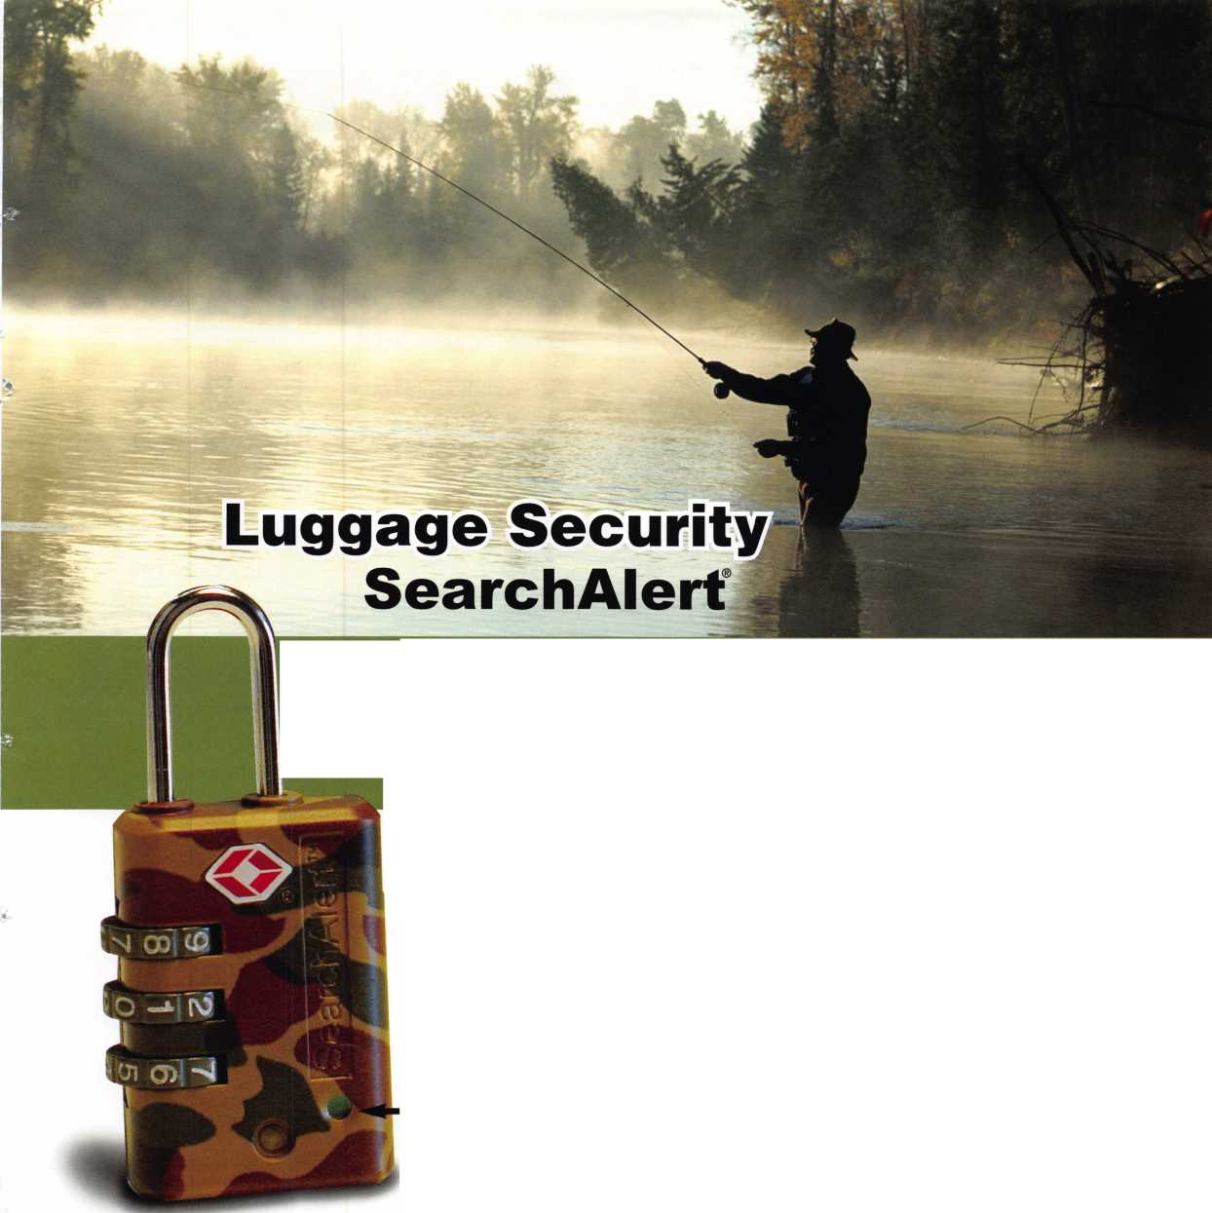

able to represent us at the many different conventions around not just the country but the world.

The show started on Friday afternoon with close to 200 exhibitors. Locksmiths from all over the country saw some of the newest prod­ucts and some old standbys. This was a great opportunity to speak

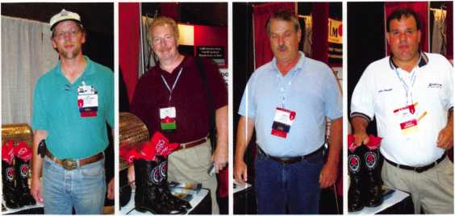

Lee Rink Barry Gelfand John Roman Mike Bronzell

New Hill, NC Bronx, NY Wilmington, MA Oaklawn, IL

Justin Boots Winners!

not just with salespeople but, in many cases, the engineers who de­sign the products we use on a daily basis. Several factories introduced new products. Schlage has a new B500 series deadbolt that will re­place the BC160 and a new version of Primus called Primus XP with a patent extending to 2024. A new deadbolt strike from Sure-Strike is now available. It has a cool feature with pins that are pushed in by the bolt making it self adjusting. If the deadbolt is not fully ex­tended, it pushes the bolt back, ensuring a properly locked bolt. Fra- mon has a new digital readout version of their model 2 machine. It is designed to allow the use of cams for preset depths and spaces mak­ing this a very versatile machine. Need an under door tool? The Ben- Jim tool company has three versions, one for levers, one for exit devices, and a cool one for knobs. All of the wholesalers had large crowds around their booths and offered great buying opportunities.

A show favorite were the new key blank references from Ilco, Strat- tec and others.

The ALOA staff and dedicated volunteers deserve a huge “thank you” and round of applause for putting this all together. Next year should prove to be one of the best conventions ever. Not only is Dallas a great location it’s also our association’s hometown. You’ll now be able to appreciate some of what goes on behind the scenes and appreciate all the ALOA employees, volunteers, and instructors do who provide you with a great education and convention.

wh

missed

Pictures:

Virtual Show: <http://alo>;

mand.

at you  
online!

.aloa.org

ia2007.tradeshowonde-

,com/



NUMBERS

Instructors:

46 Full day

40 Seminar & Workshop

Classes:

72 Full-day classes (8 hours each)

7 Evening Seminars (2 hours each)

40 Workshops (3 hours each)

Student Atten­

dees:

Sunday 39

Monday 267

Tuesday 294

full day

Tuesday 158

evening seminars Wednesday 308

full day

Wednesday 181

evening seminars Thursday 318

Friday 140

(PRP/STPRP exam) Saturday 323

Sunday 206

Instructor-led classroom hours:

710 hours

Student class hours:

12,633 hours

Certification:

234 after-class PRP 140 full PRP/STPRP

Scholarship:

There were 10 ALOA2007 Scholarship Recipients in addition to 3 that were awarded to SAVTA, ATC and Col­orado earlier in the year.

Exhibitors:

196 booths with 1401 booth personnel

Banquet

Attendees:

380

Awards:

President’s Award David O'Toole

ACE Award

Harry L. Sher, CML,

CPS

Presidential Service

Plaque

Bob Mock

Board Member Appreci­ation plaques Julie McCluney, CRL John J. Greenan, CML, CPS

NASTF

Mark Saxonberg Dave Lanspeary

Attendees:

1555 Attendees 431 Guests

International

Attendees:

Aruba 1

Australia 4

Bahamas 4

Belgium 1

Bermuda 3

Canada 35

China 1

Colombia 1

Denmark 1

Egypt 4

Guam 1

Hungary 1

Ireland 1

Israel 3

Jamaica, Wl 1

Japan 5

Korea 2

Mexico 8

New Zealand 3

Seoul Korea 4

Singapore 6

Spain 1

Sweden 1

United Kingdom 7 Venezuela 7

Keynotes • Septemeber 2007

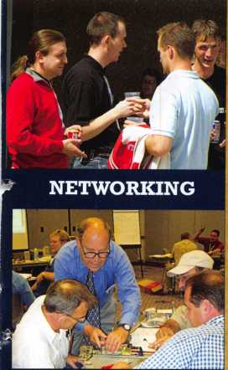

JUNE 15-22, 2008 • DALLAS, TEXAS

CLASSES

Strap on your cowboy boots! In 2008, we are cele­brating the 52nd annual ALOA Convention and Expo in Dal­las, Texas. ALOA 2008 of­fers plenty of exciting classes and seminars that will educate and expose you to some of the best security-related tech­nology the industry has to offer.

PLUS...MORE FUN!!

* Kick-Off Party
* ALOA Golf Tournament
* Tour
* Banquet
* Networking

Having built an international reputation among locksmiths as a powerful resource to ex­plore industry alliances, ALOA 2008 is the ideal place to learn, network or showcase your business on the show floor.

**For more information about Dallas, Texas please visit: www. dallascvb. com/visitors**

For more information,  
visit us on the web at  
[www.aloa.org](http://www.aloa.org), or call  
us toll free at  
800.532.2562 ext.218

CONTESTS

★ Strap on Your Cowboy Boots! Send complete information along with registration forms and a class description list.

'W Please send information regarding ALOA membership.

Name

P.nmnlpfp pnri rpti lrn thic fnrm trv AQQnr.ipfprl I nr.kQmithp nf Amprirp • .9500 Fppv Strppt • DpIIpp Tpxps 75947 • Fax: (914^ R19-975R

|  |  |  |  |
| --- | --- | --- | --- |
| Company | | | |
| Address | City | State | Zip |
| Phone | Fax | Email |  |



&

SCHOOL SECURITY **SOLUTIONS**

a

In a school crisis situation, time is critical and exposure to a threat needs to be avoided at all costs. These crisis situations are a terrifying thought but by understanding the areas where threats may penetrate a school's security, it can be identified where defenses can be strengthened. A

school's security can be categorized into three main levels; at the classroom door, interior doors and the main entrance. This overview will illustrate these three levels and explain the devices used to help alleviate intruder threats.

LEVEL ONE: MAIN ENTRANCE * PARI METER POORS

Knowing who's at the main entrance and granting to those who merit access, can greatly decrease the risk of an unwanted intruder. Aiphone's MKS-2MCD complete video door answering

system is ideally suited to remotely communicate to the main entrance and allow admittance by activating an electromechanical device such as an electric strike.

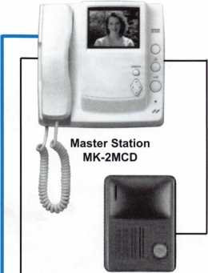

Outdoor Station  
MK-DAC

Power Supply  
PS-1820UL

0 **AIPHONE\***

MKS-2MCD

* Audio/Video Monitor
* 4” CRT Screen
* All call to other units
* Door release contact
* Instant-on when door calls
* PanTilt controlled from inside monitor stations



**Electric Strikes**

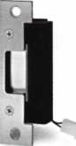

hes

5000 Series

* Tamper resistant
* 2400 lbs. static strength
* Durability minimum of 500,000 cycles of operation
* Non-handed

• .22 Amp @ 12VDC •.11 Amp@24VDC

* Built in infrared LED’s
* One power supply for entire system



300 Series

* Activate door strike from inside station(s)
* Hands free communication at the door station
* Can activate most electromechanical devices; electric strikes, electrified exits devices, and electrified locksets
* Horizontally adjustable keeper to allow for door and frame misalignment
* Dynamic strength 70 ft-lbs.
* Non-handed

•.51 Amps @ 12VDC

* .25 Amps @ 24VDC

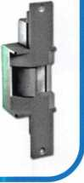

Perimeter doors are often overlooked when assessing a school’s protection plan. Egress doors in remote areas of the building pose a significant threat to an unwanted in­truder entering the school. Yale’s SquareBolt® double cylinder exit devices are a suitable solution for these areas

due to it’s patented design which incorporates a latch- bolt style retractor directly into the exit. This pre­vents the use of a credit card, crowbar, door rattling or shaking to gain access.

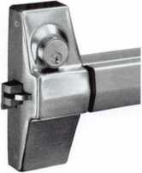

Yble SquareBolt1

7100 Series Double Cylinder

* Key outside retracts latchbolt
* Key inside locks or unlocks lever  
  •Available with rim type SquareBolt (7150-2),

Rim (7100-2) & Mortise (7130-2)

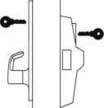

Rim Type

7100-2

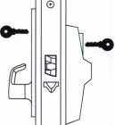

©

Mortise Type

7130-2

SquareBolt 7150-2

Shown

LEVEL TWO: CLASSROOM POORS

Being able to lock the door from the inside the classroom avoids exposure. Conventional classroom function locks require you to lock the door from the corridor side which could expose the teacher and stu­dent to potential risk. SARGENT, Corbin Russwin and Yale have provided a solution to this dilemma

with their classroom intruder functions available in cylindrical and mortise applications. This includes Sargent's 10-line and T-Zone series rose which helps to alleviate a panic situation where the person may ac­tually unlock the door in the heat of the moment.

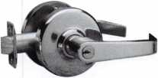

Corbin Russwin CL3300 Series

Cylindrical Lockset

Russwin^

52 Function

* Latchbolt is operated by rotating the inside lever, or rotating the outside lever only when not locked from the inside or outside by key.
* Outside lever is locked and unlocked by turning the key in the inside or outside lever.
* Inside lever cannot be locked.

Also available in the ML2000 Series Mortise

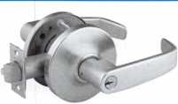

SARGENT 10-Line

Cylindrical Lockset

**SARGENT** 38 Function

* Deadlocking latch
* Latch by either lever unless outside lever is locked by key
* Key in either lever locks or unlocks outside lever
* Inside lever always operable
* Locked indication on inside rose standard with this function

Also available in the 8200 Series Mortise

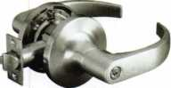

Yale

Yale 5400LN Series

Cylindrical Lockset

18 Function

* Either lever operates latchbolt, except when outside lever is locked by key.
* Outside lever is locked and unlocked by key in either inside or outside lever.
* Inside lever is always active and cannot be locked (anti-panic).

Also available in the 8800 Series Mortise

LEVEL THREE: SPECIAL PURPOSE POORS

Special doors used on such applications as computer rooms, staff lavatories and chemical labs also pose a threat to a school's security. Knowing who has access to these areas is important but it's also imperative to be able to limit that access and keep

track of persons entering through those doors. With SARGENT's enhanced v.Gl.5 Profile Series of stand­alone access control products you'll be able to provide that high level of security and convenience while mon­itoring personal.

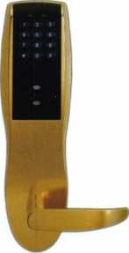

**SARGENT** Profile Series v.GI

* Increased users and audits: 2,000 users and 2,000 audits
* Password protected security management system
* Multiple user modes including passage, unlock/ relock, emergency, panic, one-time user, etc.
* Offers any activation combination for keypad, prox, and RF technology
* Long battery life (80,000 lock cycles)
* Detailed audit trail

**Available Credentials**

|  |  |  |
| --- | --- | --- |
| \ |  |  |
|  |  | n SARGENT |
| | SARGENT |  | ,000 |
|  |  |  |

SARGENT HID Prox-  
Card II™

DuoProx™ Card

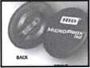

MicroProx™ Tag

PF SARGENT Prox-  
Key II™

Scammers Discover “Land of The Free”

By Jason Gage

The locksmith industry is giving a new meaning to the phrase “Land Of The Free”.

The locksmith industry is giving a new meaning to the phrase “Land Of The Free”. The locksmith industry is one of the most unregulated trades among all services. Most states do not re­quire any type of licensing, certifications, or criminal back­ground checks to own, operate or work for a locksmith company. Further more many states do not have advertising laws that require a license number on all locksmith advertise­ments. Most states do not even require a “due diligence” to be performed in order to make sure that the information provided by a locksmith company is even legitimate.

Until a few years ago I did not see a need to have any of these complicated laws brought into our trade. In fact, if you had asked me to vote on it I would have more than likely voted against it. Now I am a firm believer in the fact that we need to bring in regulatory laws to the locksmith trade more than ever. By the end of this article your perspective may change as well. In Central Florida the law states a hair stylist needs a special li­cense to be a hair stylist. In Central Florida the law also states a locksmith does not need a special license to be a locksmith. As a consumer it is quite obvious to see what the harm is by not having regulations. It is the danger of not knowing who is com­ing to your house that dark evening when you are distressed, vulnerable, and in need of someone to secure your home. Is it a felon, a sexual predator, or even an ex- convict? Well the an­swer could be none of the above. It could be someone who is in the country illegally who might mislead you, defraud you, de­stroy your locks, doors, and when he is done, give you a bone chilling feeling. When he leaves you will probably call another locksmith to secure your home from the instinctive feeling that something just wasn’t right. Now to convince a locksmith that we need regulations is a little harder and more sensitive issue. Locksmiths are a little more caught in their ways. In many cases I have found that as long as a locksmith is making a living large or small he is content. Try to take his livelihood away he is like a cobra striking his prey. The thought of getting the gov­ernment more involved in their business or livelihood scares them. They feel that if the regulations come into place it will affect their livelihood in a bad way. Some may feel this way be­cause of the fear of classes and tests, some for its failure to meet its requirements. I don’t know what the underlined part means. If locksmiths became more involved they would see that there

are many words in the ALOA bylaws which will protect them against that which they fear most.

In 2007 we are faced with an epidemic that our industry has not seen before. This epidemic started a few years ago slowly choking the life out of mobile and storefront locksmith busi­nesses across the United States. It started with the changing of time, technology, and the internet, with no new laws to follow.

It is the epidemic of the locksmith scammers, Aka Locksmith mafia, AKA, Locksmith Gypsies, AKA Fraud smiths, or what ever else your state may categorize them under.

The Scam starts with the purchase of hundreds of phone num­bers in a single local area. Many of these numbers are pur­chased through the scammer’s own phone companies who buy numbers from the main local provider. The phone numbers are then advertised in an unethical and monopolizing manner. When these numbers are advertised it is not uncommon to find a false address, and a false business name attached to them. This is done to give the customer a nice warm feeling that they are call­ing a local company that may be close to them. You will often find a more concentrated number of phone numbers with false addresses around successful locksmith shops. This is done to lure the business from legitimate locksmith stores. You see, it is a simple concept. A customer drives by a shop and sees how nice it is. A few days later he needs a locksmith and remembers the nice shop that he passed. He calls 411, goes online, or looks in the phone book to try to find the number for the shop he passed a few days before. To his amazement there are nearly 20 to choose from on the same street! The legitimate locksmith business never had a chance. The tactic of luring business in this manner is in violation of the civil Lanham Act and is a slam dunk in a federal court. These advertising schemes are also de­frauding the customer into believing they are legitimate lock­smiths in the local area.

The local phone number advertised by the scammer when called is often routed to a call center in New York. Some of these scammers are actual advertising companies out of New York and various locations across the US. These companies special­ize in monopolizing the internet, 411 systems, and the yellow pages.

**20**

Keynotes • September 2007

The scammers often use local subcontractors to run the calls re­ceived from their advertisements. The questions are, are they re­ally subcontractors or are they just a corporate layer of an organized crime ring? There are a few copycats who used to work for the companies who now practice these fraudulent busi­ness practices. Many lead back to the same place of origination; it is almost like a franchise with many layers of corporate protec­tion. Each time one layer gets removed they put another corpo­rate entity officer in place. It is like a cancer that was caught too late. These so called subcontractors arrive at jobs across the US and charge up to 10 times the going rate. Most locksmiths I have spoken with don’t understand how consumers pay such a high bill. They say that their customers squeal over their small bill with reasonable prices. After speaking with many complaining consumers’ I now see why the bills are being paid. It is a combi­nation of things I am hearing. It is the fact that they show up to the consumer’s house or car, in unmarked vehicles. They have heavy foreign accents, and they are full of threats, instilling the fear into the customer to pay.

All of the scammer’s seem to have a few things in common. The common principles of the scammer’s subcontractors seem to be unmarked vehicles, heavy foreign accents, no receipts, receipts written on service call books, receipts written on standard receipt books with their business name written in by hand, extremely high prices, not equipped with the proper tools for the job, no trade skills, destruction of customers locks and doors, answering the phone “locksmith”, and when quoting prices they quote $35 Or $45 plus labor. How are these scammers learning our lock­smith trade? The oddest part is that the locksmiths who are going out of business are being confronted by these scammers and are being asked to run service calls for them. They are also asked to train their people for a price of $300 per person per week. The once legitimate locksmiths are one by one joining the scammers for their unknown short stay. I have talked to many who were legitimate locksmiths at one time who ran calls and then trained the scammers. They all tell me that the scammers will use once legitimate locksmiths or who ever they can to train there crime ring. They advertise in their foreign magazine to re­cruit workers, when a few scammers are trained in they will part their ways with all who are not of their same race. (I don’t know what this means either)The money is attractive to the once legiti­mate locksmith at the time because they have to eat. If they only knew the damage they are causing.

We need to pass Federal Legislation for all states to at a mini­mum, require all locksmiths to register with the state and wear an ID badge with a registration number on it.

All locksmiths who advertise anywhere must post registration numbers on advertisements. All advertisements must include ac­curate registered business names and addresses (this does not limit you from listing cities just false addresses)

Each state needs to then incorporate their own individual laws.

The days of the locksmith’s Trade secrets being protected by the hometown locksmith are over. In fact my research has shown at the increasing rate of progression of scammers, with in two years we will be lucky if there are any hometown locksmiths left. The locksmiths who have not had this affect them yet, this is your fight too. It is not a matter of if is this going to aeffect you as a locksmith, but rather when. What can we do to reclaim what is rightfully ours? Well the question is, are we all willing to do our part or just a few of us? We need everyone on board to make this happen.

Please view [www.storefront-mobilelocksmith.com](http://www.storefront-mobilelocksmith.com) this is a site which has current news about the locksmith epidemic. This site offers locksmiths a free listing to locksmiths in there city. Stor- front-mobilelocksmith.com performs a du diligence on all infor­mation provided to them before adding to the directory.

For a free Listing in storefront-mobilelocksmith.com please send the following information to :

Storefrontlocksmith.com 1631 Rock Springs Rd #141 Apopka, FL, 32703

1. A copy of your occupational license
2. State if you want the address on your occupational license to be listed on your listing or just the city.
3. list the phone number you want attached to you listing
4. (Optional) Picture of your van or storefront business.

Please include your email address for contact purposes. To re­claim our livelihood, trade, respect, and piece of mind we must all do our part not a one along for a free rides.

1. Email or fax this letter along with comments to your local legislator, (Google search your city and the word legislator ex­ample “Atlanta legislator”)
2. Go to [www.aloa.org](http://www.aloa.org) click on the box “ consumer defrauded by a phony locksmith” (Click on your state and send a complaint to your states Attorney General describing this issue, send cus­tomers here as well)
3. Email and fax this article along with comments to your states FBI office (Google search your state and the word FBI example “Georgia FBI”)
4. File a complaint Internet fraud complaint government site [www.Ic3.gov](http://www.Ic3.gov)
5. Any receipts you receive that look fabricated or hand written name on the top out form 3949a tax fraud form (Google search “3949a” and send them a copy of the receipt)
6. Contact your local news and have them do a story on these scammers

Three New Schlage' Commercial Products

Launched by Ingersoll Rand Security Technologies at ALOA Security Expo 2007

At this year's ALOA 2007 Security Expo, Ingersoll Rand Security Technologies unveiled three new Schlage ® | commercial products,

Leveraging insights from locksmiths, the leading security products and services provider engineered the Schlage B- 500 Deadbolt, Schlage Primus XP and the redesigned Schlage SFIC to deliver first-rate security, reliability and easy installation.

"We've been working closely with locksmiths for more than 85 years to gain perspective on the types of security features that will help them be successful," says Derrick Marris, general manager of Commercial Security, Ingersoll Rand Security Technologies. "The three new Schlage com­mercial products were designed to address locksmiths' needs to help grow their business and make them more ef­ficient."

The Schlage B500 Deadbolt

Ideal for all commercial applications in which deadbolts are used, the new Schlage B500 Deadbolt is designed with a proprietary one-piece, deep drawn housing that delivers enhanced reliability by eliminating the potential of lock-in or lock-out situations that can occur when two-piece hous­ings separate.

The new ANSI/BHMA Grade 2 deadbolt provides excep­tional resistance to excessive force. In addition to employ­ing a throughbolt that is 10 percent larger than competitive products, the Schlage B500 deadbolt’s engage­ment to the housing is greater than .6" when the bolt is thrown and its metal dust box connects directly to the door frame.

Keynotes • September 2007

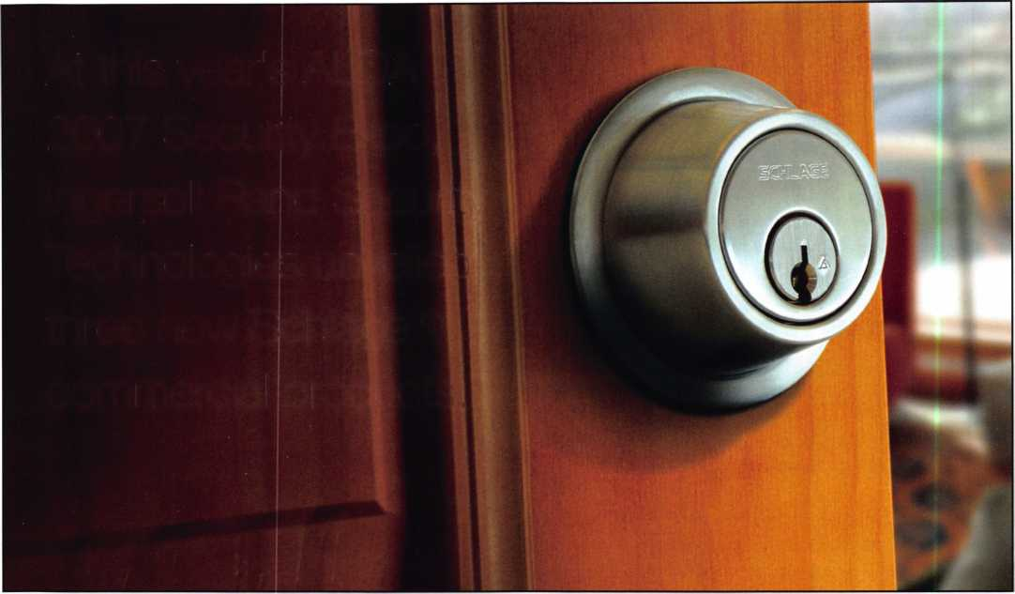

Real Security Is When Do-Overs

Take Place Only On Your Personal Time

When you install Schlage® locks, you know you've done the job right. After all, our products  
are among the most durable and dependable on the market today. They're also easy to  
install, repair and maintain, so they generate fewer callbacks. Which means you're free to  
concentrate on other things. Like learning how to pick up the 7-10 split.

Real Security Sets You Freer 3EBE3

[www.schlage.com](http://www.schlage.com)

**© 2006 IngersollRand Company Limited**

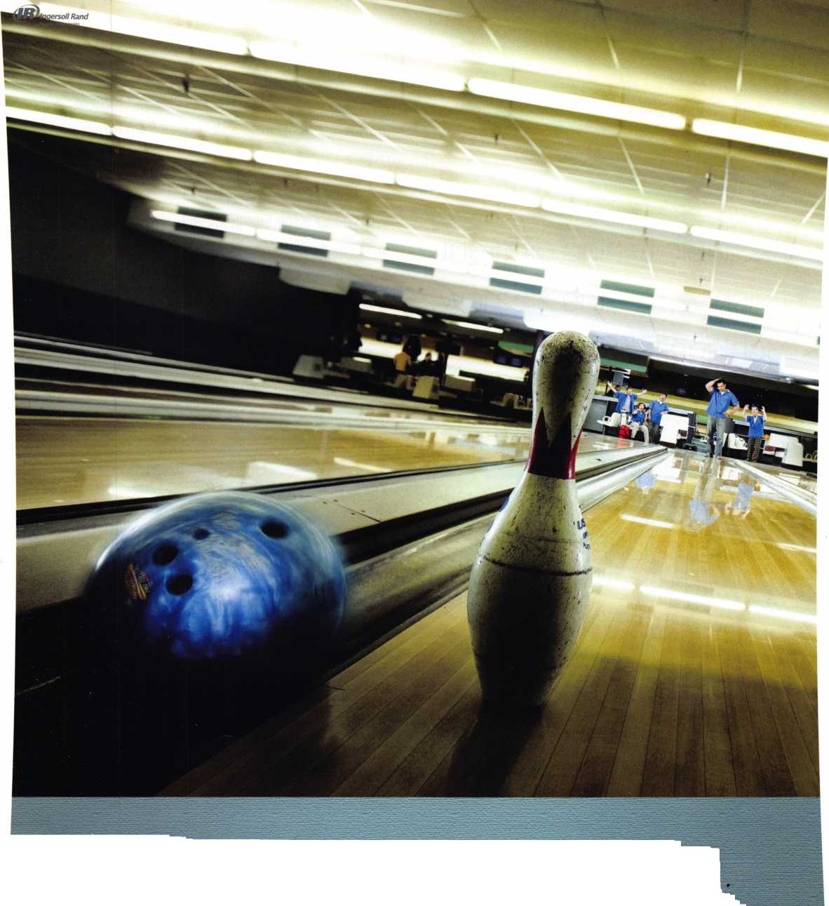

a

Available in nine different finishes, the new Schlage B500 Deadbolt also can match existing door hardware and the interior decor of any commercial facility.

To deliver reinforced vandalism protection, the dead­bolt is equipped with an anti-pry shield that covers 20 percent of the latch to prevent picking and helps to provide additional impact absorption from hammer at­tacks.

Compatible with the standard 2 1/8" cross bore, the new Schlage B500 Deadbolt can be installed in min­utes. The deadbolt comes pre-assembled; only the latch, interior and exterior components need to be in­stalled. This helps ensure that the deadbolt is properly installed every time so there are no timing issues and bolt alignment is improved by 40 percent.

Available in nine different finishes, the new Schlage B500 Deadbolt also can match existing door hardware and the interior decor of any commercial facility.

The new Schlage Primus XP

The new Schlage® Primus XP is a patented key system that provides an effective solution against unauthorized key duplication and other types of cylinder manipula­tion for a wide range of commercial applications. With its inventive design that includes a patent protection until 2024, the new Schlage Primus XP delivers the longest key management protection currently available in the market.

Similar to the original Schlage Primus system, the new key system is engineered with a multiple depth, finger pin configuration. In addition to the three "shallow" and three "deep" pins of the original Schlage Primus lock, the new Schlage Primus incorporates a new “depth” of pin. The “pocket” location on the pin is considered to be more “shallow” than any previous fin­ger pin and has a unique geometry.

**24**

Keynotes • September 2007

rnnmr

USDVA

ILLINOIS

A-1 KEY & LOCK  
24HR SERVICE  
312-555-1234

DUPLICATION

PROHIBITED

**Smart Clone**

**For All Cloneable Keys... Including Ford, Infiniti & Toyota**

**Professional Products for Professional Locksmiths**

**Smart Clone Key Blanks**

**Largest Selection of Groovy Keys Anywhere**

**Automotive**

**Transponder**

**Keys**

**Precision Key Machines and Cutters**

**Master Keying and Fine Duplication**

**View Our Complete Line of Professional Locksmith Hardware at**

**[www.jetkeys.com](http://www.jetkeys.com)**

**Jet**

**Exclusives**

**Uni Bow Neuter Bow Personal Line**

|  |  |
| --- | --- |
| KWIKSET  I KWH- | KWH- |
|  |  |

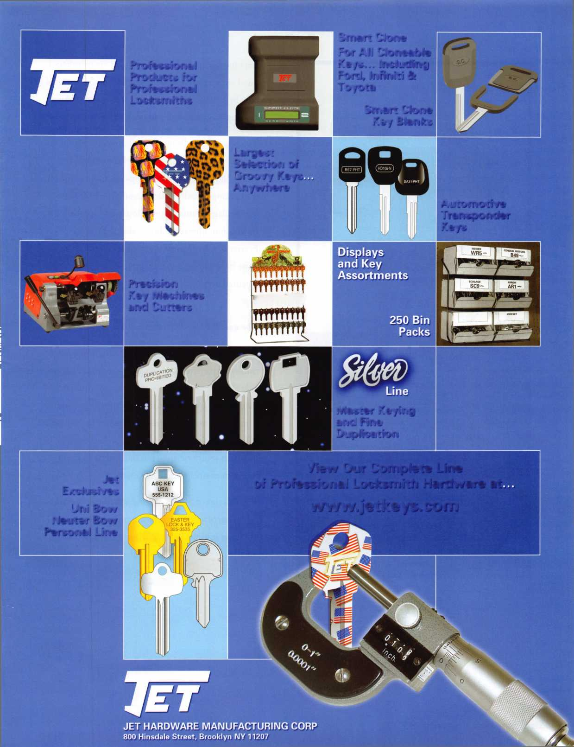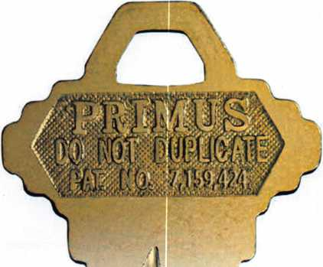

With its inventive design that includes a patent protection until 2024, the new Schlage Primus XP delivers the longest key management protection currently available in the market.

Keys for the new Schlage Primus XP are manufac­tured with a proprietary design that can be recreated only by Schlage's Master Key Department, making key duplication virtually impossible.

The new Schlage Primus XP offering is available with the current Classic Schlage Primus keyways and Schlage Everest Primus keyways and will match the existing cylinder and locks offering of the cur­rent Schlage Primus to provide an easy installation. In addition, upgrading from existing Primus,

Everest or Classic users is very simple and can be done by re-keying one finger pin to the new patented number seventh pin, and then issuing new keys.

The new Schlage Everest B SFIC

The redesigned Schlage Everest B SFIC is operated through a patented key management system to pro­vide security professionals with peace of mind. Compatible with interchangeable core locks from competitive manufacturers, the Schlage Everest B SFIC can be instantly used to replace a core and maintain security during instances when keys are lost or personnel changes are made.

The redesigned SFIC is engineered using a sophisti­cated, burr-free manufacturing process that drills pin holes into the locks individual components dur­ing the pre-assembly phase, rather than after the core has been assembled. This controlled process



Keynotes • September 2007

“In a locksmith pick test, the  
redesigned SFIC showed a  
significant reduction in the  
quantity of picked cores...”

provides a core tolerance that delivers excellent resistance to cylinder manipulation. In a locksmith pick test, the re­designed SFIC showed a significant reduction in the quan­tity of picked cores, which was lower than competitive products.

Additionally, the seven-pin core is noticeably easier to oper­ate than its competitors, requiring 60 percent less force for insertion and rotation. The cores accurate design also helps to reduce the amount of time spent with core maintenance by minimizing key breakage and extending the life of the cylinder.

Available in three stylish finishes, the redesigned ANSI/BHMA Grade 1 SFIC can match almost any existing

lock to provide a consistent look within a facility or office environment.

Continued Leadership

Through attending industry events and conferences, such as ALOA's Security Expo, Ingersoll Rand Security Technolo­gies is dedicated to working in close cooperation with lock­smiths to design first-rate security products that can help them gain a competitive advantage.

For more information on Ingersoll Rand Security Technolo­gies' value-added products and services that make environ­ments safe, secure and productive, please visit [www.securitytechnologies.ingersollrand.com](http://www.securitytechnologies.ingersollrand.com).

Keynotes • September 2007

**2**

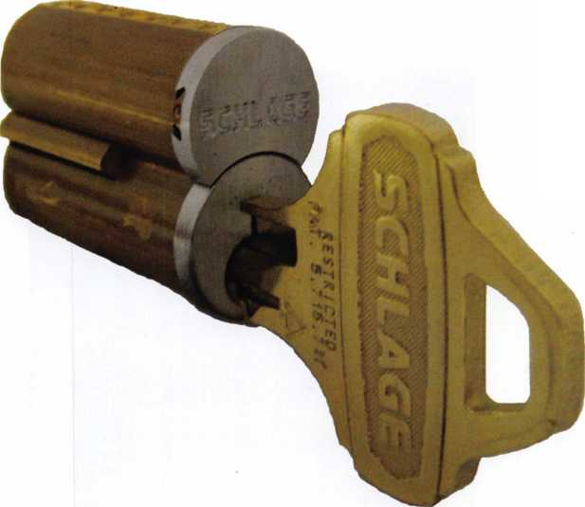

You want what locked?

By Greg Perry, CML, CPS

I want the bathrooms locked up today! Perhaps a little bit of a strange request but if that’s what the customer wants and it does­n’t violate some code, we can ac­commodate it.

The customer wanted some means to lock the bathrooms at night but open all day. It seems they were having trouble with some night contractors messing with the main office bathroom. A classroom function lock might work but a better solution is to use an electronic push­button lock that has a time schedule to leave it unlocked during the day and automatically lock at the appropriate time each night. I looked at the job and after discussing it with the customer and offering the electronic version we set the job for the next day and ordered parts. Pro­viding the right locks for this job was the easy part, the hard part was the installation. Their hollow metal doors were not prepared for locks. All of you have probably installed locks in wood doors but how many of you in­stall locks in hollow metal doors and how do you like to perform the install?

There are two basic styles of unprepared doors; first is the style partially prepared on the edge of the door for a mortise lock or the typical cylindrical lock latch with the faces left blank. The other style has no preparation. These doors appeared to be one of each, fortunately the frames were prepared for the ANSI 4 7/8” strike. The frame preparation dictates the height to mount the lock. So let’s start with the unprepared door. This door re­quires a hole on the edge for the latch and also the face

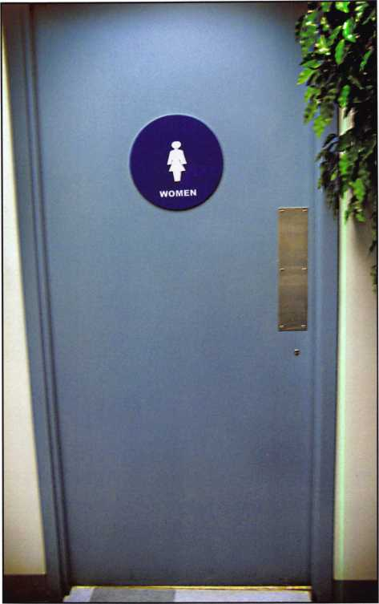

bored for the lockset and the upper wireway hole. First locate the exact location to match the strike cutout.

Next it’s time to bore some holes in the door. Typically I drill the faces of the door and the edge using a boring fixture and hole saws. The next step depends on your tool selection and door construction. Some of you may own either the “Squeezeplay” from Bob Seivking or the “Pit Bull” from Major Manufacturing. These tools allow the door edge to be formed into a recess to accept the latch faceplate. This door would have been a good can­didate for forming in this way. The other option is to cut the 1 1/8” by 2 1/4” rectangle and use a latch-mounting



Keynotes • September 2007



**H.L. Flake Co.**

Over 95 years of quality service

You are never more than 3 days away!

FREE FREIGHT is just  
a small order away!

FREE GROUND FREIGHT WITH:

L- 1 $ 95.00 order

1 Isiis.00 order mi $135.00 order

FREE FREIGHT  
(excludes key machines, safes, & bulk key orders)  
(within contiguous 48 states)

BUSINESS DAYS

3 DAYS AWAY

2 DAYS AWAY

OVER WEEKENDS, ADD 2 DAYS

Please know that if you have a preference on your delivery carrier, it may extend the delivery time of your package. The delivery time will not exceed 3 business days.



**ivww.hlf/ake.** com

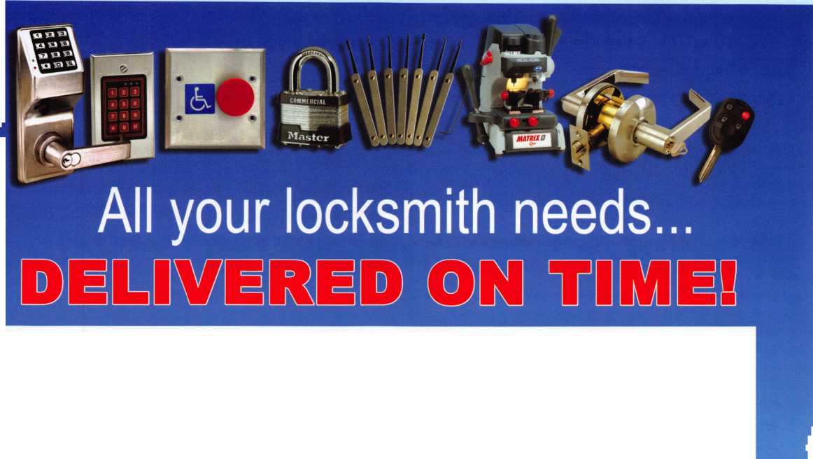

bracket. The choice can be made for you if the door has a center seam; the center seam will not allow the use of a forming tool. The latch-mounting bracket from Major Mfg. has the cutouts top and bottom to allow for the cen­ter seam, it also comes with an adhesive back template. This was the option chosen for this door. Cutting this opening can be done with several different tools. After a hole has been cut with a drill bit or hole saw the rectangle shape can be cut with a saber or jig saw with a metal cut­ting blade. A “Dremel” or rotary cutout tool will make this cutout but it can also scar the door quickly. I’ve also used a 1/4” carbide bit in a router but this can be difficult to control and perhaps dangerous if the bit should break. Any of these methods require hearing protection, safety glasses, a full-face shield, and perhaps gloves.

The other door required a little different approach. I was a little unprepared for this door as when I looked at the doors I missed that they were different. First the metal mortise pocket hole filler and the body putty were re­moved. Next a latch support from a retrofit kit made by Best was used to support the latch. Normally I would have used one made by DonJo which is the full thickness, the Best version is made of thinner material requiring some washers between the filler and the tabs in the door. It also has the latch hole centered; the DonJo version is offset. Sometimes centered is the appropriate location other times it’s not. This was the case here, so it required cutting the strike hole down a little.

The balance of the install for both doors was the same. After drilling the faces of the doors and getting the latch supports in place, interior supports from ESP were in­stalled to prevent the doors from being crushed as the lock screws were tightened down. These were perhaps unnecessary, as the footprint of the locks is fairly large spreading the stress across a large area of the door com­pared to a standard cylindrical type lock. Once the locks were completely installed a different issue needed to be

addressed. One of the doors was sagging. The top hinge needed to be replaced or bent back into shape. GKL In­dustries makes the “Hinge Doctor” line of tools. These bend the hinge back into shape. Simply by placing the appropriate tool over the hinge and then opening the door against it the hinge is bent to compensate for the sagging. Although I often replace the hinge these tools are a quick and easy fix. Be careful not to over bend the hinge or the door might not close all the way.

Lock installs come in many styles and forms with differ­ent needs. Having the appropriate parts, tools, and tech­niques are important. In this case the customer gave me an extra day to complete the install, but they wanted the job completed. Having a few extra parts in the truck like the latch support can make the difference between getting the job completed as promised or having to go back for more parts and having an unhappy customer.

( \

You need it When?

**How about now!? :-)**



Another Special  
Value-added Benefit to your

ALOA Membership! Click here..



[www.clearstar.com](http://www.clearstar.com) / ALOA

v /



Keynotes • September 2007



ALOA 2007

Can You Find Yourself?

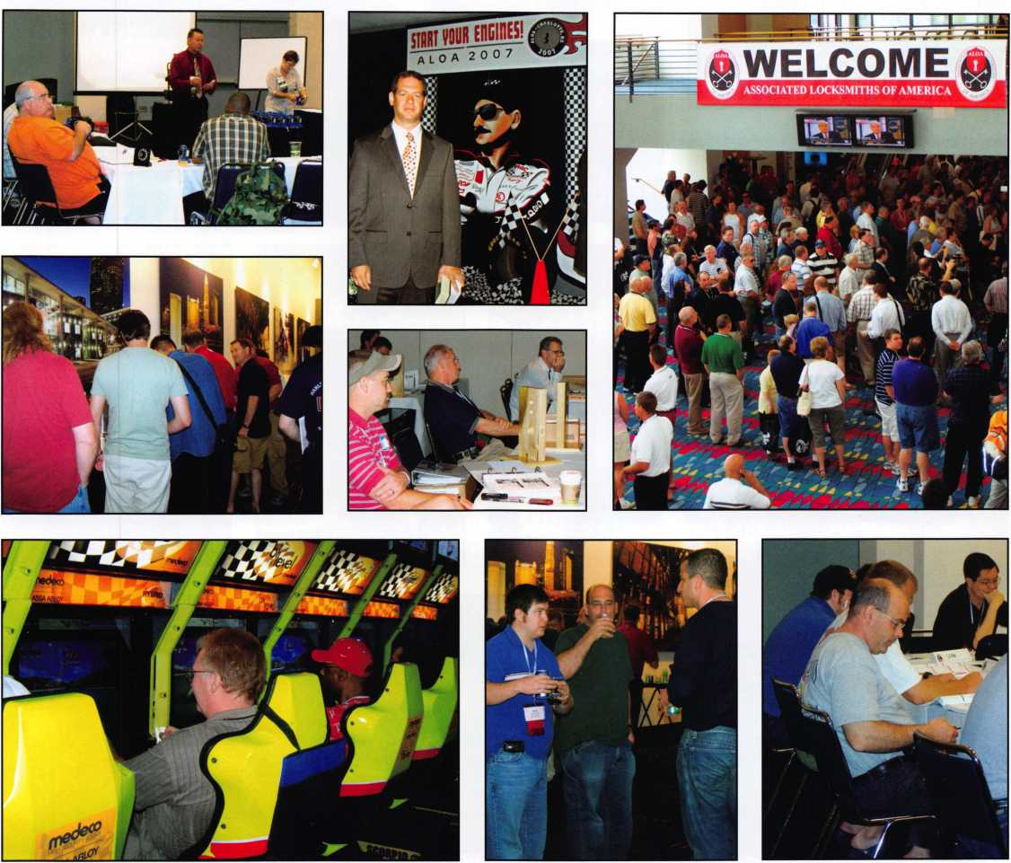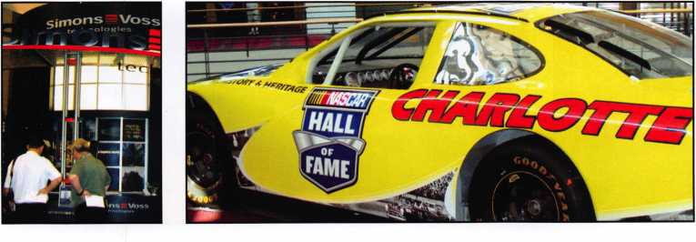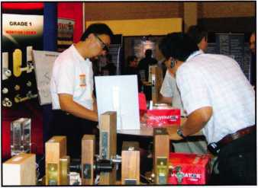

Keynotes • September 2007

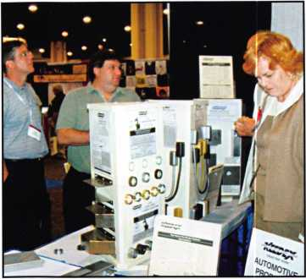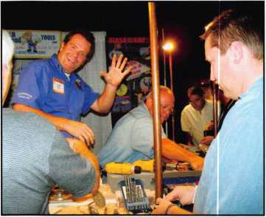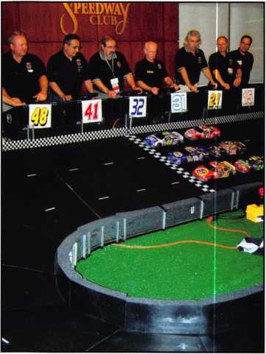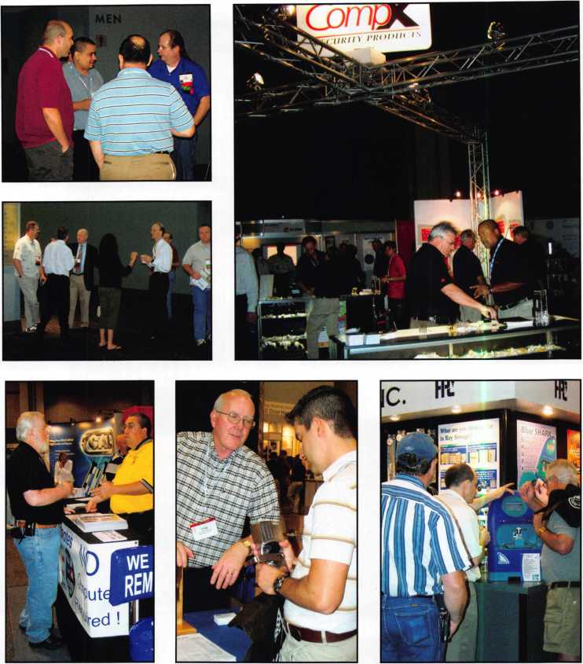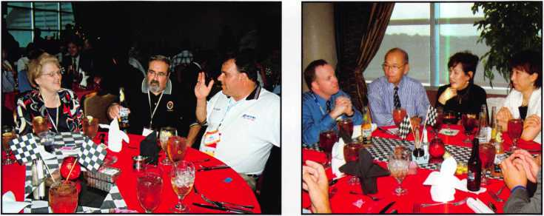

Keynotes • September 2007

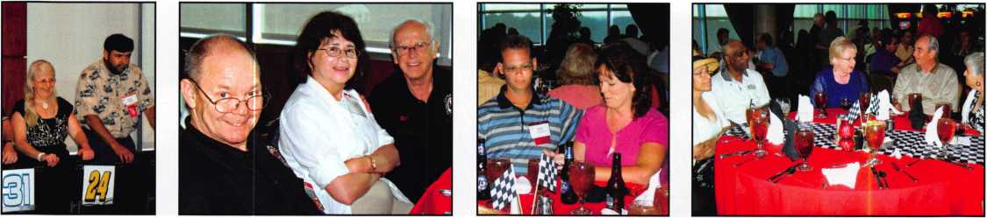

Access Control

r .

Securitylnc access control kits feature:

* All necessary software, hardware and readers in one package
* Configuration Wizard - Program up to 16 doors instantly
* N-1000-IV-X* Retrofit capabilities
* More digital Inputs, Outputs and Power than our competitors
* Quick Start Wiring Guide for ease of installation

4 doors, at the price of 2 doors!!!

Securitylnc access control kits are now available at:

**Atlanta Miami Tampa**

**Atlanta**

**800.726.3332**

**Miami**

**800.827.3332**

**800.272.5184**

***INTERNATIONAL DISTRIBUTION NETWORK***

ll/ll

t IDN-ARM STRONG’S, INC. I

**Norfolk**

**Raleigh**

**Jacksonville**

**Nashville**

**800.673.3330 866.849.0032**

**Orlando**

**800.735.3334 800.341.7857 800.775.1220**

For additional information, email us today!  
[sales@securityinc.com](mailto:sales@securityinc.com)

*SECURITY me*

[www.securityinc.com](http://www.securityinc.com)

**\* N-1000-IV-X is a registered trademark of Honeywell Access Sytems**

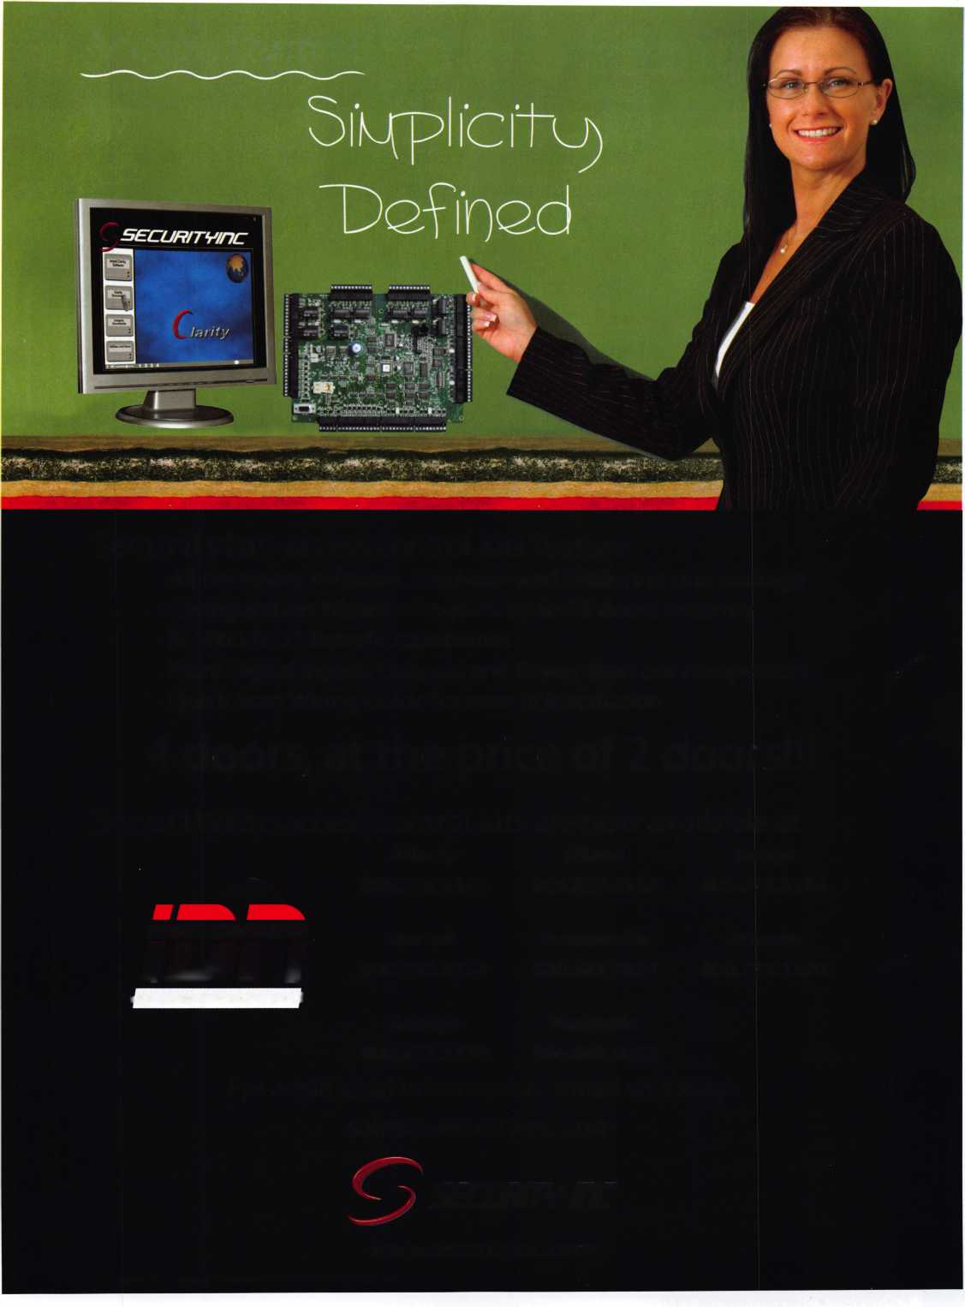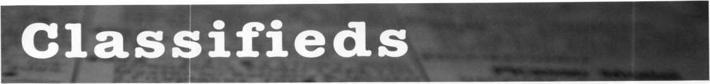

EMPLOYMENT

EXPERIENCED LOCKSMITHS

Join our staff at John Koons Locksmiths in Southwest Florida. Positions in one of our shops or outside service are available. We offer health insurance and vacation. Hous­ing is also available for quali­fied applicants. Call George Klein at 1-800-282-8458 or fax a resume to 239-931- 6203. John Koons Locksmiths, 3526 Fowler Street, Fort Myers, Florida 33901.

SERVICE TECHNICIAN WANTED IN CHICAGO

Full time position, installing and servicing Access Control and Electronic Door Hard­ware, with experience only. Union job with excellent bene­fits. Please fax resume to 312- 850-6701, attention: Pat or email

[pglavin@glavinlock.com](mailto:pglavin@glavinlock.com).

No phone calls please.

LOCKSMITH WANTED

Busy shop in Woburn, Massa­chusetts seeks experienced Locksmith. We perform com­mercial, residential, safe,

glass storefronts, card access and automotive work includ­ing 2 AAA accounts. You don't have to know all these phases of locksmithing and we are also willing to train if interested. Sub contractors welcome - your van or ours. For more info please contact John at 781-933-9999 or send resume to:

Locks & Keys, Inc., P.O. Box 222, Woburn, MA01801.

LOCKSMITH WANTED

Established company with 30+ years in business in Hampton Roads, Virginia is seeking locksmith with experi­ence in residential, commer­cial, and automotive work. Knowledge in servicing safes, medeco locks and electronic access control a plus. Appli­cant must be neat in appear­ance self motivated, have good driving record and be able to pass background and drug testing.

We offer full benefits pack­age, competitive wages, med­ical insurance, paid vacation and sick days, education and profit sharing. Send resume

to: Shorty Wallin Lock and Security. Fax 757-722-5520 or email to:

[swallin@shortywallin.com](mailto:swallin@shortywallin.com)

WANTED TO BUY/SELL

SPECIAL PRICING ON KWIKSET & SCHLAGE!

While supplies last on the fol­lowing: Kwikset 2421xUS3 - $30 each. 690Tx5 - $15 each. 665x5 - $12 each. 400Tx5 - $7 each. 341x3 Screen door lock - $7 each. Schlage B162x626 - $ 16 each. All FOB in Michigan. Call Cheryl atA-1 Brown Locksmith Locksmith & Hard­ware, 269-982-0569

FOR SALE

1 Used ILCO 024 Semi-Auto­matic key machine - $250.00. 1 used HPC Trace A Key Model 6666 Automatic key machine - $250.00. All prices plus shipping. Call 313-881-0280 or email: [eastsidelock@sbc- global.net](mailto:eastsidelock@sbc-global.net)

Keynotes • September 2007

LOCKSMITH BUSINESS FOR SALE

Locksmith Business for sale in beautiful Galveston Island, Texas. Address: 1624 21 Street, 77550. Owner retiring after 33 years due to health. Many commercial, residential, real estate, industrial ac­counts. Very well established. Equipment and inventory in­cluded. Over 20,000 keys in stock. Includes 2001 Ford Club Econoline van, 2 Bravo Key Machines, 2 Curtis Clip­per's #15 all accessories for all cars and all car opening tools and much more. Two blocks from beach. Business is booming. More than we can handle. Business name only selling for $325,000 obo with option to buy property. Location corner lot with house on side of business. All for $599,000 firm. Please seri­ous inquiries only. Call 409- 765-9551 daytime or 409-789-8487 only til 9pm Mon-Fri. VJ. Tramonterealty.com 409-765-9837.

MOBILE LOCKSMITH BUSINESS FOR SALE

Mobile Locksmith Business for Sale in the thriving Coachella Valley in Southern California. If you're an experienced lock­smith with a current California locksmith permit, here's a chance to be in business for yourself. Be your own boss and work towards your own dreams and goals instead of your employers'. For details, contact David, or leave a message at 760-772-0153.

FOR SALE -

LOCKSMITH BUSINESS

Locksmith Business near south­west suburbs of Chicago (Evergreen Park/Oak Lawn area). Retiring due to health. Business includes many com- merical and automotive ac­counts with twenty eight year customer base. Sale includes telephone number, 2003 Dodge Sprinter with 63,000 miles, all equipment including Triax high security machine Ultra Code Bravo key ma­chine, HPC 1200 with attac- ments for Tibbi key,

T code, NGS, tubular key ma­chine, GM ten cut and six cut system and many tryout keys. Also includes Trip lite inverter, many priming kits (foreign and domestic) all cabinetry and stock merchandise. For further information and price all Frank at 708-422-4808.

FOR SALE

Medeco Manual Key Ma­chine. Cuts both level I and II. Excellent condition - used. $2000 plus shippping. Code book included. Also used Scotsman Key Machine 747X. Cuts standard size keys only. $300 plus shipping. Call Joe Rick at AAA Distributors, Buf­falo, NY 716-856-2261.

8:30 a.m. - 5:00 pm EST

FOR SALE

3 HPC Machines: Trace A Key, Punch, Blitz, Opening tools Tryout keys, determina­tors, blanks, about $18,000 near new- need resonable offer. Call Al at 602-291- 3500.

Classified Advertising Policy

Classified advertising space is provided free of charge to ALOA members and for a fee of $2.00 per word, $40.00 minimum for non members. Classified ads may be used to advertise used merchandise and overstocked items for sale, "wanted to buy" items, business opportunities, employment opportunities/positions wanted and the like. Members or non members wishing to advertise services or new merchandise for sale may purchase a "Commercial Classified Ad" for a fee of $4.00 per word with a minimum of $100.00. Each ad will run for two issues. For blind boxes there is a $10.00 charge for members and non members. All ads must be submitted in writing to the Advertising Sales Department via fax at 817-645-7599 or through an email to [adsales@aloa.org](mailto:adsales@aloa.org) by the fifteenth of the month two months prior to issue date. ALOA reserves the right to re­fuse any classified advertisement that it deems inappropriate according to the stated purpose of the classified advertising section.



Keynotes • September 2007



associate

members

Distributor

**1 st In Hardware, Inc.**

Phone: 410-646-9900 Fax: 410-646-0045 www. 1 stinhardware.com

**ADEL Fingerprint Technology, LLC**

Phone: 909-595-1222 Fax: 909-595-1667

**Accredited Lock Supply Co.**

Phone: 800-652-2835 Fax: 201-865-2435 [www.acclock.com](http://www.acclock.com)

**American Auto Lock.Com**

Phone: 717-392-6333 Fax: 717-581-8353 [www.americanautolock.co](http://www.americanautolock.co) m

**Boyle & Chase Inc.**

Phone: 800-325-2530 Fax: 800-205-3500 [www.boyleandchase.com](http://www.boyleandchase.com)

**Clark Security Products**

Phone: 858-974-6740 Fax: 858-974-6720 [www.clarksecurity.com](http://www.clarksecurity.com)

**Cook's Building Specialties**

Phone: 505-883-5701 Fax: 505-883-5704

**Dire's Lock & Key Company**

Phone: 303-294-0176 Fax: 303-294-0198

**Direct Security Supply, Inc.**

Phone: 800-252-5757 Fax: 800-452-8600

**Doyle Security Products**

Phone: 800-333-6953 Fax: 612-521-0166 [www.doylesecurity.com](http://www.doylesecurity.com)

**Dugmore and Duncan, Inc.**

Phone: 888-384-6673 Fax: 888-329-3846

**E. L. Reinhardt Co., Inc.**

Phone: 800-328-1311 Fax: 651-481-0166 [www.elreinhardt.com](http://www.elreinhardt.com)

**Foley-Belsaw**

**Company**

Phone: 800-821-3452 Fax: 816-483-5010 [www.foley-belsaw.com](http://www.foley-belsaw.com)

**Fried Brothers Inc.**

Phone: 800-523-2924 Fax: 215-592-1255 [www.fbisecurity.com](http://www.fbisecurity.com)

**H.L. Flake Co.**

Phone: 800-231-4105 Fax: 713-926-3399 [www.hlflake.com](http://www.hlflake.com)

**Hardware Agencies, Ltd.**

Phone:416-462-1921 Fax: 416-462-1922 [www.hardwareagencies.com](http://www.hardwareagencies.com)

**IDN Incorporated**

Phone: 817-421-5470 Fax: 817-421-5468 [www.idn-inc.com](http://www.idn-inc.com)

**Instant Hardware Delivery, Inc**

Phone: 800-355-1 107 Fax: 800-663-851 8

**Intermountain Lock & Security**

Phone: 800-453-5386 Fax: 801-485-7205 [www.imlss.com](http://www.imlss.com)

**Jovan Distributors, Inc**

Phone: 416-288-6306 Fax: 416-752-8371 [www.jovanlock.com](http://www.jovanlock.com)

**L V Sales Inc**

Phone: 323-661-4746 Fax: 323-661-1314 [www.lvsales.com](http://www.lvsales.com)

**Lockmasters, Inc.**

Phone: 859-885-6041 Fax: 859-885-7093 [www.lockmasters.com](http://www.lockmasters.com)

**Locks Company**

Phone: 800-288-0801 Fax: 305-949-3619

**Locksmith Ledger International**

Phone: 847-454-2700 Fax: 847-454-2759 [www.lledger.com](http://www.lledger.com)

**McDonald Dash Locksmith Supply Inc.**

Phone: 800-238-7541 Fax: 901-366-0005 [www.mcdonalddash.com](http://www.mcdonalddash.com)

**NLS Lock Supply Dba Nevada Lock Supply**

Phone: 702-737-0500 Fax: 702-737-7134

**Omaha Wholesale Hardware**

Phone: 800-238-4566 Fax: 402-444-1664 [www.omahawh.com](http://www.omahawh.com)

**Phoenix Safe International LLC**

Phone: 765-483-0954 Fax: 765-483-0962 [www.phoenixsafeusa.com](http://www.phoenixsafeusa.com)

**Positive Identity Solutions**

Phone: 704-663-1 175 Fax: 704-660-1301 [www.pids-usa.com](http://www.pids-usa.com)

**Security Distributors Inc**

Phone: 800-333-6953 Fax: 612-524-0166

**Southern Lock and Supply Co.**

Phone: 727-541-5536 Fax: 727-544-8278 [www.southernlock.com](http://www.southernlock.com)

**Stone & Berg Wholesale**

Phone: 800-225-7405 Fax: 800-535-5625

**The Locksmith Store Inc.**

Phone: 847-364-51 1 1 Fax: 847-364-5125 [www.locksmithstore.com](http://www.locksmithstore.com)

**The Ultimate Distribution Company**

Phone: 254-681-2277 Fax: 254-953-4933 [www.ultimatelocksales.com](http://www.ultimatelocksales.com)

**Timemaster Inc.**

Phone: 859-259-1878 Fax: 859-255-0298 [www.time-master.com](http://www.time-master.com)

**Top Notch Distributors, Inc.**

Phone: 570-753-5625 Fax: 570-253-7178 [www.topnotch.bz](http://www.topnotch.bz)

**Turn 10 Wholesale**

Phone: 800-848-9790 Fax: 800-391-4553

**U.S. Lock Corp.**

Phone: 800-925-5000 Fax: 800-338-5625 [www.uslock.com](http://www.uslock.com)

Manufacturer

**A & B Safe Corporation**

Phone: 800-253-1267 Fax: 856-863-1208 [www.a-bsafecorp.com](http://www.a-bsafecorp.com)

**ABUS KG**

Phone: 492-335-634151 Fax: 233-563-4130 [www.abus.com](http://www.abus.com)

**ABUS Lock Company**

Phone: 800-352-2287 Fax: 602-516-9934 [www.abus.com](http://www.abus.com)

**Access Security Products Ltd.**

Phone: 905-337-7874 Fax: 905-337-7873 [www.access-safe.com](http://www.access-safe.com)

**Accu-Key Lock & Safe Inc**

Phone: 937-294-4241 Fax: 937-294-6565

**Adams Rite Mfg Company**

Phone: 800-872-3267 Fax: 800-232-7329 [www.adamsrite.com](http://www.adamsrite.com)

**Adrian Steel Company**

Phone: 800-677-2726 Fax: 517-265-5834 [www.adriansteel.com](http://www.adriansteel.com)

**Advanced Diagnostics USA Inc**

Phone: 650-876-2020 Fax: 650-876-2022 [www.autokeys.com](http://www.autokeys.com)

**Alarm Controls Corporation**

Phone: 631-586-4220 Fax: 631-586-6500 [www.alarmcontrols.com](http://www.alarmcontrols.com)

**All Five Tool Company, Inc.**

Phone: 860-583-1691 Fax: 860-583-4516 [www.all5tool.com](http://www.all5tool.com)

**American Security Products**

Phone: 909-685- 9680x2013 Fax: 909-685-9685 [www.amsecusa.com](http://www.amsecusa.com)

**BMG Door Hardware Inc**

Phone: 714-572-0977 Fax: 714-572-0978 [www.bmgdh.com](http://www.bmgdh.com)

**Bianchi USA, Inc.**

Phone: 800-891-2118 Fax: 216-803-0202 [www.bianchi](http://www.bianchi) 1770usa.com

**Buddy Products**

Phone: 312-733-6400 Fax: 312-733-8356 [www.buddyproducts.com](http://www.buddyproducts.com)

**CCL Security Products**

Phone: 800-733-8588 Fax: 847-537-1800 [www.cclsecurity.com](http://www.cclsecurity.com)

**CompX Security Products**

Phone: 864-297-6655 Fax: 864-297-9987 [www.compx.com](http://www.compx.com)

Keynotes • September 2007

associate

members

**D&D Technologies (USA), Inc.**

Phone: 714-677- 1300x292 Fax: 714-677-1299 [www.ddtechglobal.com](http://www.ddtechglobal.com)

**DETEX Corp.**

Phone: 800-729-3839 Fax: 830-620-671 1 [www.detex.com](http://www.detex.com)

**Don-Jo**

**Manufacturing, Inc.**

Phone: 978-422-3377 Fax: 978-422-3467 [www.don-jo.com](http://www.don-jo.com)

**Door Controls International**

Phone: 800-742-3634 Fax: 800-742-0410 [www.doorcontrols.com](http://www.doorcontrols.com)

**Doorking Inc.**

Phone: 800-826-7493 Fax: 310-641-1586 [www.doorking.com](http://www.doorking.com)

**Dorma Architectual Hardware**

Phone: 717-336-3881 Fax: 717-336-2106 [www.dorma-usa.com](http://www.dorma-usa.com)

**DynaLock Corp**

Phone: 860-582-4761 Fax: 860-585-0338 [www.dynalock.com](http://www.dynalock.com)

**FireKing Security Group**

Phone: 800-457-2424 Fax: 800-896-6606 [www.fireking.com](http://www.fireking.com)

**Framon Manufacturing Company Inc.**

Phone: 989-354-5623 Fax: 989-354-4238 [www.framon.com](http://www.framon.com)

**G-U Hardware Inc.**

Phone: 757-877-9020 Fax: 757-877-9720 [www.g-u.com](http://www.g-u.com)

**HPC, Inc.**

Phone: 847-671-6280 Fax: 847-671-6343 [www.hpcworld.com](http://www.hpcworld.com)

**HY-KO Products Co.**

Phone: 330-467-7446 Fax: 330-467-7442

**Hammerhead Industries, Inc.**

Phone: 805-658-9922 Fax: 805-658-8833 [www.gearkeeper.com](http://www.gearkeeper.com)

**Ingersoll Rand**

**Security**

**Technologies**

Phone: 317-810-3801 Fax: 317-805-5779 [www.schlagelock.com](http://www.schlagelock.com)

**Jackson Corporation**

Phone: 323-269-8111 Fax: 800-888-6855 [www.jacksonexit.com](http://www.jacksonexit.com)

**Jet Hardware Mfg., Co.**

Phone: 718-257-9600 Fax: 71 8-257-0973 [www.jetkeys.com](http://www.jetkeys.com)

**KABA ILCO Corp.**

Phone: 252-446-3321 Fax: 252-446-4702 [www.kaba-ilco.com](http://www.kaba-ilco.com)

**KEY-BAK/West Coast Chain Mfg.**

Phone: 909-923-7800 Fax: 909-923-0024 [www.keybak.com](http://www.keybak.com)

**Kenstan Lock Company**

Phone: 516-576-

9090x315

Fax: 516-576-0100

[www.kenstan.com](http://www.kenstan.com)

**Keri Systems Inc.**

Phone: 408-435-8400 Fax: 408-435-7163 [www.kerisys.com](http://www.kerisys.com)

**Kustom Key Inc.**

Phone: 800-537-5397 Fax: 800-235-4728 [www.kustomkey.com](http://www.kustomkey.com)

**LAB Security**

Phone: 800-243-8242 Fax: 860-583-7838 [www.labpins.com](http://www.labpins.com)

**Lucky Line Products, Inc.**

Phone: 858-549-6699 Fax: 858-549-0949 [www.luckyline.com](http://www.luckyline.com)

**M.A.G.**

**Manufacturing**

Phone: 714-891-5100 Fax: 714-892-6845

[www.magmanufacturing.com](http://www.magmanufacturing.com)

**MPT Industries, Inc.**

Phone: 973-989-9220 Fax: 973-989-9234 [www.mptindustries.com](http://www.mptindustries.com)

**MUL-T-LOCK USA, Inc.**

Phone: 800-562-351 1 Fax: 973-778-4007 [www.mul-t-lockusa.com](http://www.mul-t-lockusa.com)

**Maxcess Card Systems Inc**

Phone: 800-713-4823 Fax: 650-692-9410 [www.maxcess-card.com](http://www.maxcess-card.com)

**Medeco Security Locks**

Phone: 540-380-5000 Fax: 540-380-5010 [www.medeco.com](http://www.medeco.com)

**Mil-Comm Products Co Inc**

Phone: 201-935-8561 Fax: 201-935-6059

**Pacific Lock Company**

Phone: 888-562-5565 Fax: 818-678-6600 [www.paclock.com](http://www.paclock.com)

**Protex Safe Co., LLC**

Phone: 818-610-8030 Fax: 818-610-8004 [www.protexsafe.com](http://www.protexsafe.com)

**RA-Lock Company**

Phone: 800-777-6310 Fax: 972-775-6316 [www.ralock.com](http://www.ralock.com)

**ROFU International Corp.**

Phone: 253-922-1828 Fax: 253-840-7272 [www.rofu.com](http://www.rofu.com)

**Rutherford Controls Int'l Co.**

Phone: 519-621-7651 Fax: 519-621-7939 [www.rutherfordcontrols.c](http://www.rutherfordcontrols.c) om

**Sargent &**

**Greenleaf, Inc.**

Phone: 859-885-9411 Fax: 859-885-3063 www. sa rgenta ndg reen- leaf.com

**Sargent**

**Manufacturing Co.**

Phone: 800-727-5477 Fax: 888-863-5054 [www.sargentlock.com](http://www.sargentlock.com)

**Schwab Corp.**

Phone: 765-447-9470 Fax: 765-447-8278 [www.schwabcorp.com](http://www.schwabcorp.com)

**Securifort Inc**

Phone: 819-359-2226 Fax: 819-359-2218 [www.securifort.com](http://www.securifort.com)

**Securitron Magnalock Corp.**

Phone: 775-355-5625 Fax: 775-355-5636 [www.securitron.com](http://www.securitron.com)

**Security Door Controls**

Phone: 805-494-0622 Fax: 805-494-8861 [www.sdcsecurity.com](http://www.sdcsecurity.com)

**Security Solutions**

Phone: 405-376-1600 Fax: 405-376-6870 www. security solution s- usa.com

**Select Engineered Systems**

Phone: 305-823-5410 Fax: 305-823-5215 [www.selectses.com](http://www.selectses.com)

**Townsteel, Inc.**

Phone: 626-858-5080 Fax: 626-858-3393 [www.townsteel](http://www.townsteel) .com

**Trine Access Technology**

Phone: 718-829-2332 Fax: 718-829-6405 [www.trineonline.com](http://www.trineonline.com)

**Videx Inc.**

Phone: 541-758-0521 Fax: 541-752-5285 [www.videx.com](http://www.videx.com)

**WIKK Industries Inc.**

Phone: 414-421-9490 Fax: 414-421-3158 [www.wikk.com](http://www.wikk.com)

**WMW Innovation Company**

Phone: 888-474-2341 [www.sure-strike.com](http://www.sure-strike.com)

Service

Organization

**Allstate Insurance Company**

Phone: 847-551-2181 Fax: 847-551-2732 [www.allstate.com](http://www.allstate.com)

**HRH Insurance**

Phone: 817-462-3630 Fax: 817-462-3680 [www.hrh.com](http://www.hrh.com)

**Red Hawk**

Phone: 901-332-291 1 Fax: 901-332-2878

[www.webstersinc.com](http://www.webstersinc.com)

**The Mechanic Group, Inc.**

Phone: 845-735-0700 Fax: 845-735-8383

[www.mechanicgroup.com](http://www.mechanicgroup.com)

Keynotes • September 2007

**3**



**KEYNOTES - SEPTEMBER**

2007 CONVENTION LEGISLATIVE HIGHLIGHTS

For those of you who were not able to make the 51 st Celebration of ALOA in Charlotte, North Carolina, you missed some great legislative meetings! Here are the highlights:

State of the States Roundtable

More than 30 representatives from ALOA chapters and locksmith associations across the US and Europe met to share concerns, ideas and updates on what is happening in their states and countries. ALOA's Legislative Manager Tim Mc­Mullen, JD, CAE began the meeting high­lighting the bills introduced in 2007 that affected the security industry (see below).

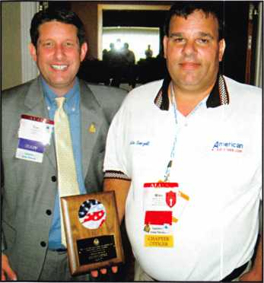

Mike Bronzell receiving the "Legislative  
Action Network Person of the Year Award"

The first hour was devoted to discussing the "phony locksmiths" infestation and how this problem is personally affecting many locksmiths' own businesses. ALOA members Mike Bronzell and Jason Gage have taken the lead to educate lock­smiths, the government and the media on this growing problem. Outgoing ALOA President, Bob E. Mock encouraged members to contact their Regional Direc­tors when they become aware of a prob­lem with phony locksmiths in their area.

Tim also announced that ALOA is work­ing with the Better Business Bureau on a follow up press release to educate con­sumers on how to complain to their state's Attorney General by going to <http://www.aloa.org/AGMap/AG.htm>.

For the final hour chapter and associa­tion leaders took turns describing the many issues facing their states. Florida, Georgia, Maryland and Wisconsin spoke about their efforts to introduce locksmith licensing laws for 2008.

Make sure you don't miss next year's roundtable at the ALOA Convention in Dallas, Texas!

Legislative Action Network Council Re­ception

ALOA celebrated the efforts of its grass­roots legislative team at the annual Leg­islative Action Network (LAN) Council Reception. ALOA's Legislative Manager Tim McMullen, JD, CAE thanked every­one for their hard work to make this year so successful for the locksmith industry. Special awards were given to members who went above and beyond duty to pro­mote the locksmith industry in their state and nationally. Legislative Action Net­work Person of the Year award was pre­sented to John E. Brueggeman for his tireless work on passing the motor vehi­cle keycode access bill in California.

Mike Bronzell was recognized as Legisla­tive Action Network Person of the Year for his extensive work nationally on the "phony locksmith" issue.

The Legislative Action Network (LAN) welcomed four new Council members (those donating $100 or more to the ALOA Legislative Fund). Special thanks goes out to John B. Arnold, CML (TX), Mike Bronzell (IL), Jason Gage (FL), John W. Soderland, CML, CMST, CIL (Wl).

The Legislative Action Network (LAN) Council is an important instrument in rais­ing the standards of our profession

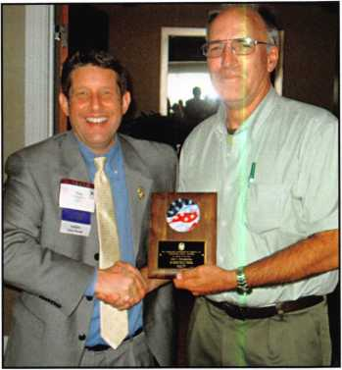

John E. Brueggeman receiving the "Leg-  
islative Action Network Person  
of the Year Award"

through the legislative process by making sure that locksmiths have the final say in how our industry will be run. For more information on how to become a Council member visit [www.aloa.org/legislation](http://www.aloa.org/legislation) and click on "Join the Legislative Action Network".

POSTMASTER GENERAL NOW RE­GARDS "BUMP KEYS" AS NON-MAIL­ABLE LOCKPICKING TOOLS

ALOA worked closely with a number of physical security manufacturers to make the mailing of "bump keys" a federal crime. The Postmaster General recently issued an official opinion declaring that "bump keys" fall under the definition of "locksmithing devices," which are consid­ered to be non-mailability under current federal law. The law (39 USC 30 §3002a) makes it a crime to mail "lock- smithing devises" to anyone other than a lock manufacturer or distributor, a bona fide locksmith, a bona fide repossessor or a motor vehicle manufacturer or dealer. Now, if an individual is caught mailing a "bump key" they could be fined up to $1,000 or imprisoned up to one year, or both (1 8 USC 83 § 1716A).



Keynotes • September 2007

**BRIGHTEN** YOUR  
FUTURE. **HIGHLIGHT**YOUR SUCCESS!



**SAFE & VAULT**

**TECHNICIANS ASSOCIATION CONVENTION & TRADE SHOW**

**SAN DIEGO**

**CALIFORNIA**

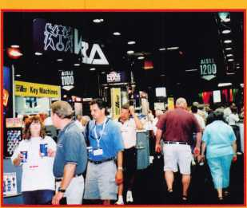

Highlight your path to the future with the latest technology the industry has to offer to safe technicians at SAFETECH 2008. Exposure to today’s top safe distributors and manufac­turers is absolutely crucial to making good purchasing and sales decisions. Additionally, time is of the essence when it comes to education. New de­velopments spring up each year, making top-notch safe

classes a necessity in our ever- changing environment.

SAFETECH classes cover sub­jects related to the installation, maintenance and operation of sales and vaults at levels from novice to expert. The only chance to get world-class edu­cation and meet with the in­dustry’s top distributors and manufacturers is at the 2008 Safe & Vault Technicians Con­vention & Trade Show.

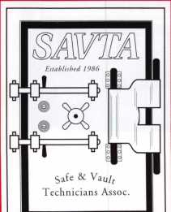

**SAFETECH** 2008

**March 31 -April 5, 2008  
Bahia Resort Hotel  
San Diego, California**



**[www.savta.org](http://www.savta.org) • 214.819.9771**

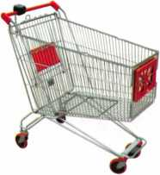

keynotes

Buyer's Mar



f-1



**SAFE CORPORATION**

**NIW** ROTARY HOPPER SAFE

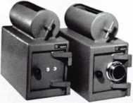

WHEN YOU NEED A SMALLER  
CAPACITY WITH THE SAME  
SECURITY OF OUR LARGER SAFES

ask for AB-3M

with a dual key or combination lock

A & B SAFE CORPORATION 800-253-1267 114 S. Delsea Drive, Suite 3 856-863-1186

Glassboro, NJ 08066 Fax 856-863-1208

IN-STOCK...MORE SAFES

***FREE Freight Program***

***(30 States)***

AMSEC RreKing

Bardall **hayman**

MEILINK y/CTOn

**TURH lO**

**WHOLESALE SERVICE**

800-848-9790

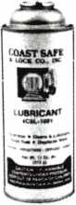

Using a general purpose lubricant? **Be professional!** Use a specially formulated lubricant for the Locksmith and Safe Technician trade. You and your customers will be well pleased. **Guaranteed!**

$48°° + shipping per case.

12 -1 loz. cans per case minimum order.  
Order via phone or fax. Credit cards accepted.  
Net 30 W.A.C. or send check with order.

Coast Safe & Lock Co., Inc.

P.O. Box 66257 • Mobile, AL 36606  
(251) 479-5264 • Fax (251) 471-6967

**CHECK A CREDIT CARD STATE-OF-THE-ART**

**SAVE TIME. ELIMINATE RISK. SAVE MONEY!**

MMEsmM

**NO NSF’s!**

No More Bad Checks

& No More Driving to the Bank with Deposits!

la*

Offer your Clients the Convenience of Paying by  
Visa, MasterCard, Discover or American Express  
Attract New Customers, Improve Cash Flow

**ON-THE-SPOT FUNDS AUTHOR**I**ZAT**IO**N**!  
**DEPOSITS WIRE-TRANSFERRED TO  
ANY CHECKING ACCOUNT!**

*VIS*

*rm*

■lie.

Payment Processing Technologies LLC. is registered ISO/MSP of Chase Paymentech  
Solutions, LLC., Electronic Check Conversion & Guarantee Services by Global eTelecom

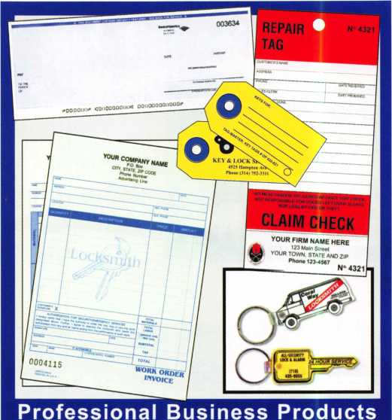

Invoices Tags *Call for a free*

Checks Key Fobs *brochure and samples*

**Business Magnets 1-800-355-6322**

Cards Labels [www.pbp2000.com](http://www.pbp2000.com)

Keynotes • September 2007

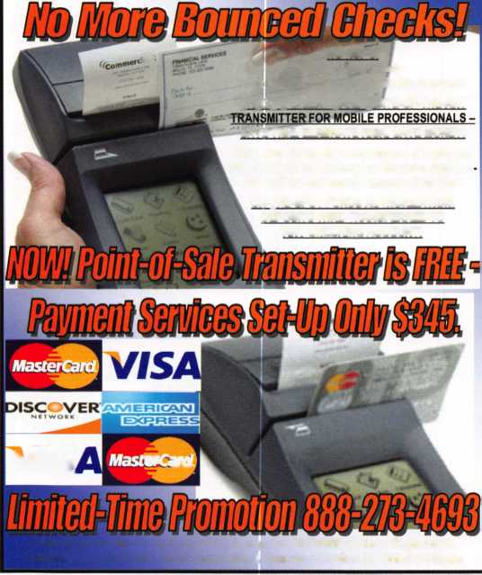

T.M.

KWH PERFORMANCE POWERED HAND TRUCKS

***OPERATOR SAFETY***

Injuries can be virtually eliminated. Ultra Lift does the lift-  
ing so that operator effort required to complete a move is  
minimized. Heavy loads are broken back with ease. The  
operator stays in control by using a combination of motor  
power, balance and leverage in every phase of a move.

***REDUCE LABOR COSTS***

Fewer people are required for any move with Ultra Lift.  
Manpower can be scheduled more productively. Labor  
savings often pay for the Ultra Lift in one month.

***ELIMINATE DAMAGE***

Loads are broken back, set down and moved under power  
with maximum leverage and operator control. Gentle  
handling eliminates bumps, bounces and damage to the  
load and premises.

***INCREASE PROFITS***

Increased operator safety, reduced labor cost and elimina-  
tion of damage to the load and premises all contribute to  
significant increases in profits.

FOR LITERATURE, VIDEO OR ON-SITE  
DEMONSTRATION, WRITE OR CALL:

ULTRA LIFT CORPORATION

475 STOCKTON AVENUE, UNIT E  
SAN JOSE, CA 95126  
800-346-3057  
408-287-9400  
FAX 408-297-1199

ULTRA LIFT supplies the power — so you don't have  
to. One person can safely and easily handle loads  
that usually require 2 or B people, even up or down  
stairs. Two people can handle most safes to 1500  
pounds. If safety is your concern, ULTRA LIFT is the  
best move you'll ever make!

E-mail: [info@ultralift.com](mailto:info@ultralift.com) [www.ultralift.com](http://www.ultralift.com)

**U.S. PATENT 4.570.953**

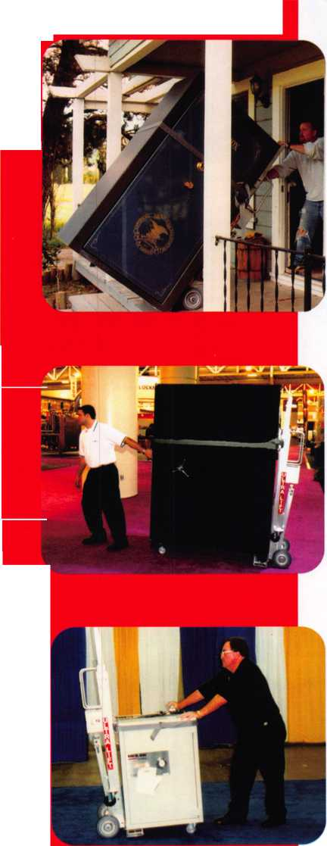

KONTROLLING A KWIKSET

By John A. Nassour, CRL

Kwikset has come out with a new lock called the  
Smart Key System. This lock can only be purchased  
at Home Depot at present. There is no service kit  
for these locks available to the Locksmith. How-  
ever, this lock is not that hard to service.

These locks work similar to the old-style  
U-Change locks which have been on the  
market for a long time.

Re-keying is very simple if you have an existing key:

No need to remove the lock from the door. Just in-  
sert the operating key, turn 90 degrees to the right,  
insert the Smart Key change key and push in, re-  
lease, remove old key, insert new key and rotate  
back to key removal position.

If no key is available, you can generate an operating  
key by doing the following steps:

Fitting a key to the Kwikset Smart Key Knob Cylin-  
der when no key is available:

1. Remove the cylinder by using you flat cylinder  
   removable tool.
2. Remove the larger “U” shaped clip and slide out  
   the core from the housing. (Note: you do not  
   need to use a follower)
3. Mark the change key (or a small pick) 1/8”  
   from the tip the determine the proper cuts  
   for the key.
4. Progress each cut until the depth of the wafer is  
   1/8” below the housing.
5. Use the operating key to re-key other locks in  
   the system.

To generate an operating key, progress each cut  
until all wafers are 1/8” below the surface of the  
cylinder.

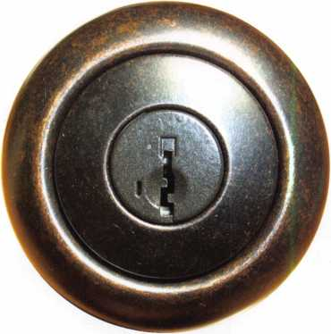

Key Cylinder with change

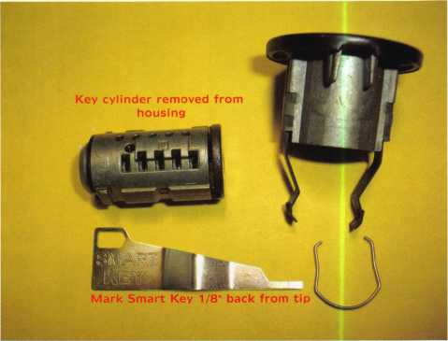

key slot on side of keyway

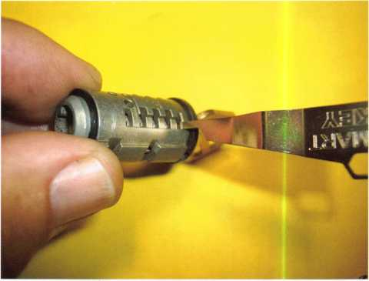

Key cylinder showing side bar wafers

Note: when the proper key is inserted in the cylinder all of the side bar wafers  
are at the same depth, approximately 1/8” as shown above.

Keynotes • September 2007

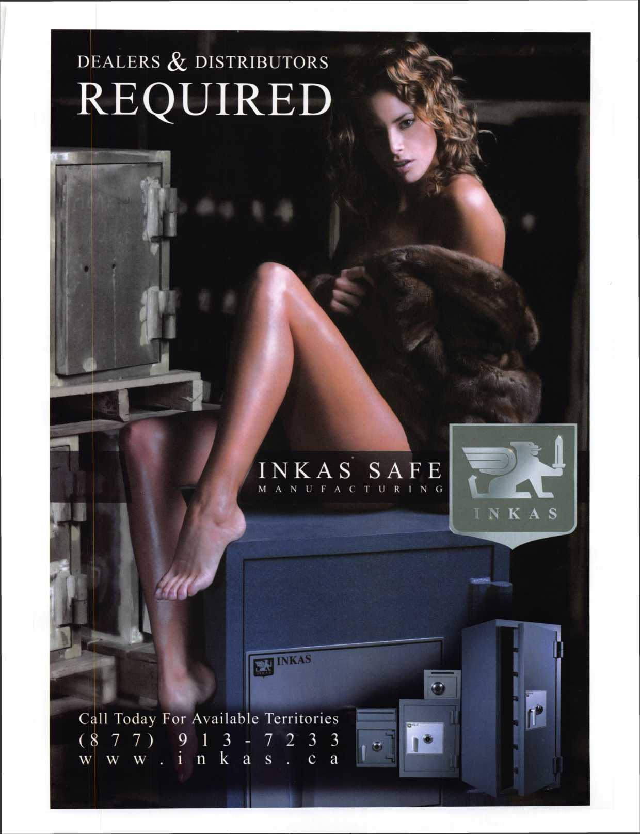

Craft

your own career

in Locksmithing

Learn to be a locksmith at our conveniently  
scheduled hands-on morning program. Classes  
are given from 7:30 am - 12:30 pm. Over nine  
months you will learn to service, install and  
bypass a wide variety of locking devices including

residential, commercial and automotive locks. Master keying, electronic  
access, and safe manipulation round out a curriculum which is updated  
annually to incorporate the latest industry advancements. September and  
February admissions.

Other full-time courses offered are • Bookbinding • Cabinet & Furniture  
Making • Carpentry • Preservation Carpentry • jewelry Making & Repair  
• Piano Technology • Violin Making & Repair

Financial aid is available for qualified students. Accredited member ACCSCT. Non-accredited workshops 1 week to 3 months also offered.

NOKTH-BENNET-STREET-SCHOOL

AN EDUCATION IN CRAFTSMANSHIP 39 North Bennet St. • Boston, MA 02113 • (617) 227-0155

[www.nbss.org](http://www.nbss.org)

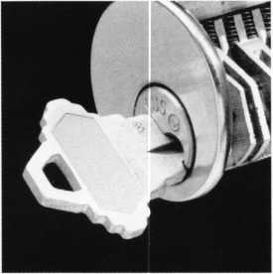

Your Customers Need This

Current security products only alert homeowners that they have already been violated.

Your customers will actually be able to sleep secure the night after a break-in. Helps eliminate tenant initiated damage and secures vacant units for landlords.

This Will Change Your Business

* You should make $1,000 on every call that you answer with this product
* Calling a carpenter to fix shattered jambs costs you money
* This will help you sell more high-end deadbolts

Ml lln \/nn lAinrl/ \A/ith anw lanrllnrHe?

niiciGiid

Needed Most

) Hinge Shield

ie Hinge Shields fit around the existing Dor hinges and help prevent hinges from eing kicked in

I Poor Shield

ie Door Shield reinforces the lock area of e door and helps prevent the door from fitting when kicked. Low profile model available in colors to match your locks

I Jamb Shield

he backbone of the system, the Jamb hield is a 48" long sleeve that wraps round the lock side of the doorjamb, laking it extremely difficult to kick in. he Jamb Shield comes sizes to fit tandard (5.5") and Universal (5" to 12”) ick spacing. Jamb and hinge shields

**A unique system that  
reinforces the key strike  
points on entry doors  
and repairs damage  
from previous kick-ins**

**Because You Can’t Afford False Security®**

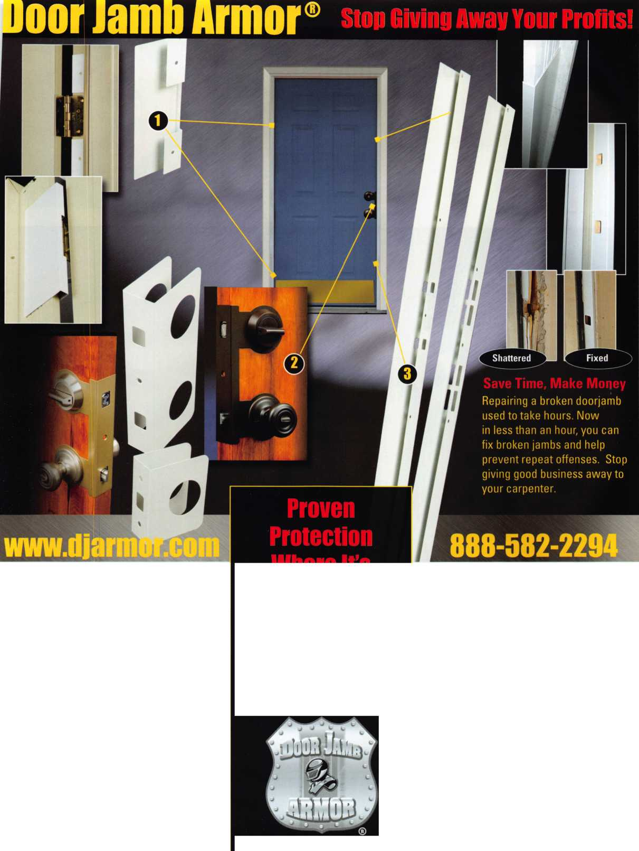

Flexibility **Merged** With Security... Now, In A Retrofit Cylinder.

**[www.medeco.com](http://www.medeco.com)**



Medeco’s new Electronic Cylinder platforms merge the flexibility of electronics with proven mechanical technologies-all in a retrofit cylinder. Three exc ting new product lines-Logic, Hybrid Key, and Hybrid Cylinder-offer end-users audit trails, custom access schedules, and the ability to

quickly add or remove a key from a system. And, unlike other stand-alone or access control products, Medeco E-Cylinders install in a matter of minutes without any wiring, door modifications, or related hardware. Learn more by calling 800-839-3157 or visit Medeco.com

HIGH SECURITY LOCKS

ASSA ABLOY

ASSA ABLOY, the global leader in door opening solutions

